**MCQs on The Indian Contract Act, 1872 Part 1**

**Q.1:- The person making the proposal is called the and the person accepting the proposal is called :**

1. Proposor/ Proposee
2. Promisee/ Promisor
3. Promisor/Promisee
4. Proposee/ Proposor

Correct Option: C

**Q.2:- Every promise and every set of promises, forming the consideration for each other, is called as:**

1. A voidable contract
2. A contract
3. A void contract
4. An agreement

Correct Option: D

**Q.3:- An agreement enforceable by law is:**

1. A voidable contract
2. Void
3. A contract
4. A void contract

Correct Option: C

**Q.4:- An agreement which is enforceable by law at the option of other or others is:**

1. A contract
2. A voidable contract
3. Void
4. A void contract

Correct Option: B

**Q.5:- The Indian Contract Act, 1872 extends to:**

1. The State of Jammu and Kashmir.
2. The Union Territories of India
3. The whole of India except the State of Jammu and Kashmir.
4. The whole of India.

Correct Option: C

**Q.6:- The Act which deals with the matters relating to the contract is titled as:**

1. The Contract Act, 1872
2. The Indian Contract Act, 1872
3. The Indian Contract Act, 1882
4. The Indian Contract Act, 1972

Correct Option: B

**Q.7:- An agreement not enforceable by law is said to be:**

1. A contract
2. Void
3. A voidable contract
4. A void contract

Correct Option: B

**Q.8:- When the communication of a proposal is complete:**

1. When it do not comes to the knowledge of the person to whom it is made.
2. When it comes to the knowledge of another person that some communication was made to the concerned person.
3. When it comes to the knowledge of the person to whom it is not made.
4. When it comes to the knowledge of the person to whom it is made.

Correct Option: D

**Q.9:- When an acceptance may be revoked:**

1. An acceptance may be revoked at any time before the communication of the acceptance is complete as against the proposer, but not afterwards.
2. An acceptance may be revoked at any time before the communication of the acceptance is complete as against the acceptor, but not afterwards.
3. An acceptance may be revoked at any time before the communication of the acceptance is incomplete as against the acceptor, but not afterwards.
4. An acceptance may be revoked at any time after the communication of the acceptance is complete as against the acceptor, but not afterwards.

Correct Option: B

**Q.10:- In order to convert a proposal into a promise, the acceptance must:**

1. Be absolute and qualified.
2. Be expressed in some usual and reasonable manner, unless the proposal prescribes the manner in which it is to be accepted.
3. Be absolute and unqualified
4. Both B and C only.

Correct Option: D

**Q.11:- When a proposal may be revoked:**

1. A proposal may be revoked at any time when the communication of its acceptance is complete as against the proposer, but not afterwards.
2. A proposal may be revoked at any time before the communication of its acceptance is incomplete as against the proposer, but not afterwards.
3. A proposal may be revoked at any time before the communication of its acceptance is complete as against the proposer, but not afterwards.
4. A proposal may be revoked at any time after the communication of its acceptance is complete as against the proposer, but not afterwards.

Correct Option: C

**Q.12:- A contract which ceases to be enforceable by law becomes void when it ceases to be:**

1. Void
2. Voidable
3. Enforceable
4. Unenforceable

Correct Option: A

**Q.13:- The Indian Contract Act,1872 which was enacted on 25 April, 1872 came into force with effect from:**

1. 1st May, 1872
2. 1st September, 1872
3. 1st October, 1872
4. 1st November, 1872

Correct Option: B

**Q.14:- A ‘proposal’ is defined as:**

1. When one person signifies to another his willingness to do or to abstain from doing anything, with a view to obtaining the assent of that other to such act or abstinence, he is said to make a proposal.
2. When one person signifies to another his willingness to do, with a view to obtaining the assent of that other to such act or abstinence, he is said to make a proposal.
3. When one person signifies to another his willingness to do or to abstain from doing anything, he is said to make a proposal.
4. When one person signifies to many persons his willingness to do or to abstain from doing anything, with a view to obtaining the assent of that other to such act or abstinence, he is said to make a proposal.

Correct Option: A

**Q.15:- An agreement was entered into with the minor. This is agreement is:**

1. Void
2. Voidable
3. Bad
4. Illegal

Correct Option: A

**Q.16:- Where a minor has entered into a contract for purchase of necessary items. In such cases:**

1. The minor is not personally liable.
2. Minor’s estates are liable to make good.
3. Minor’s guardian is liable.
4. The minor is personally liable

Correct Option: A

**Q.17:- 6. Consent is defined as:**

1. Two or more persons are said to consent when they agree.
2. Two or more persons are said to consent when they agree upon the same thing in the same sense.
3. Two or more persons are said to consent when they understand the same thing.
4. Two or more persons are said to consent when they agree upon the same thing.

Correct Option: B

**Q.18:- Consent is said to be free when it is not caused by:**

1. Very much influence
2. Undue influence
3. Slightly influence
4. Influence

Correct Option: B

**Q.19:- A, being in debt to B, the money lender of his village, contracts a fresh loan on terms which appear to be unconscionable. This will be termed as:**

1. Fraud
2. Coercion
3. Undue influence
4. Misrepresentation

Correct Option: C

**Q.20:- When consent to an agreement is caused by coercion, fraud or misrepresentation, the agreement is a contract :**

1. Voidable at the option of the party whose consent was so cause.
2. Illegal
3. Depends upon the circumstances of the case.
4. Void

Correct Option: A

**Q.21:- If the consent was caused by misrepresentation or by silence, fraudulent within the meaning of section 17, the contract, nevertheless, if the party whose consent was so caused had the means of discovering the truth with ordinary diligence:**

1. may be voidable
2. may not be not voidable
3. is voidable
4. is not voidable Correct Option: D

**Q.22:- A fraud or misrepresentation which did not cause the consent to a contract of the party on whom such fraud was practised, or to whom such misrepresentation was made, does not render a contract:**

1. Void
2. Voidable
3. Bad
4. Illegal

Correct Option: B

**Q.23:- Where both the parties to any agreement are under a mistake as to a matter of fact essential to the agreement,**

1. The agreement is voidable.
2. The agreement can’t be enforceable at law.
3. The agreement is void.
4. The agreement is not void.

Correct Option: C

**Q.24:- When consent to an agreement is caused by undue influence, the agreement is a contract**

1. Bad
2. Void
3. Illegal
4. Voidable at the option of the party whose consent was so cause

Correct Option: D

**Q.25:- What is a sound mind for the purposes of contracting:**

1. A person is said to be of sound mind for the purposes of making a contract, if, at the time when he makes it, he is capable of understanding it and of forming a rational judgement as to its effect upon his interest.
2. A person is said to be of sound mind for the purposes of making a contract, if, at the time when he makes it, he is capable of understanding it.
3. A person is said to be of sound mind for the purposes of making a contract, if, he is capable of understanding it and of forming a rational judgement as to its effect upon his interest.
4. A person is said to be of sound mind for the purposes of making a contract, if, at any time when he makes it, he is capable of understanding it and of forming a rational judgement as to its effect upon his interest.

Correct Option: A

**Q.26:- Who are competent to contract:**

1. Every person is competent to contract who is of the age of majority according to the law to which he is subject, and who is of sound mind and is not disqualified from contracting by any law to which he is subject.
2. Every person is competent to contract who is of the any age and who is of sound mind and is not disqualified from contracting by any law to which he is subject.
3. Every person is competent to contract who is of the age of majority according to the law to which he is subject.
4. Every person is competent to contract who is of the age of majority according to the law to which he is subject, and who is of sound mind.

Correct Option: A

**Q.27:- What agreements are contracts:**

1. All agreements are contracts if they are made by the free consent of parties competent to contract, for a lawful consideration and with a lawful object, and are not hereby expressly declared to be void.
2. All agreements are contracts if they are made by the free consent of parties competent to contract, for a lawful consideration and with a lawful object, and may or may not be expressly declared to be void.
3. All agreements are contracts if they are made by the consent of parties competent to contract, for a lawful consideration and with a lawful object, and are not hereby expressly declared to be void.
4. All agreements are contracts if they are made by the free consent of parties competent to contract, for any object, and are not hereby expressly declared to be void.

Correct Option: A

**Q.28:- Every agreement by which any party thereto is restricted absolutely from enforcing his rights under or in respect of any contract, by the usual legal proceedings in the ordinary tribunals, or which limits the time within which he may thus enforce his rights:**

1. Is valid.
2. Is voidable
3. Is void.
4. Is illegal

Correct Option: A

**Q.29:- The agreements which are in restraint of trade are;**

1. Valid
2. Illegal
3. Void
4. Voidable

Correct Option: C

**Q.30:- The consideration must be:**

1. Adequate
2. Must be adequate
3. Need not be adequate
4. Substantially adequate

Correct Option: C

**Q.31:- An agreement in restraint of the marriage of a major persons is:**

1. Legal
2. Illegal
3. Void
4. Voidable

Correct Option: C

**Q.32:- If any part of a single consideration for one or more objects, or any one or any part of any one of several considerations for a single object, is unlawful:**

1. The agreement is void.
2. The agreement is voidable.
3. The agreement is enforceable.
4. The agreement is unenforceable.

Correct Option: A

**Q.33:- A contract is not voidable because it was caused by a mistake as to any law in force in India; but mistake as to a law not in force in India has the same effect as:**

1. A mistake of case
2. A mistake of fact
3. A mistake of law
4. A mistake of understanding

Correct Option: B

**Q.34:- A contract is not voidable merely because it was caused by one of the parties to it being under a mistake as to:**

1. A mistake of fact
2. A mistake of law
3. A mistake of case
4. A mistake of understanding

Correct Option: A

**Q.35:- The consideration or object of an agreement is lawful, unless:**

1. The Court regards it as immoral, or opposed to public policy.
2. It is forbidden by law or Is of such a nature that, if permitted, it would defeat the provisions of any law.
3. Is fraudulent or involves or implies injury to the person or property of another.
4. All of the above

Correct Option: D

**Q.36:- An erroneous opinion as to the value of the things which forms the subject-matter of the agreement, is not to be deemed:**

1. A mistake as to a matter of law
2. A mistake as to a matter of fact.
3. A mistake of circumstances
4. A mistake of nature of transactions

Correct Option: B

**Q.37:- A and B make a contract grounded on the erroneous belief that a particular debt is barred by the Indian Law of Limitation:**

1. The contract illegal.
2. The contract is not voidable.
3. The contract is voidable.
4. The contract is void.

Correct Option: B

**Q.38:- The consideration may be:**

1. Past
2. Present
3. Future
4. All the options are correct.

Correct Option: D

**Q.39:- A ‘contingent contract’ is a contract to do or not to do something, if some event collateral to such contract:**

1. Happened or will not happen
2. Does or does not happen
3. May or may not happen
4. None of the above.

Correct Option: B

**Q.40:- If the event becomes impossible, such contracts becomes:**

1. Illegal
2. Bad
3. Void
4. Voidable

Correct Option: C

**Q.41:- A wagering contract is .................. whereas a contingent contract is........................ :**

1. Void/valid
2. Valid/void
3. Valid/voidable
4. Voidable/valid

Correct Option: A

**Q.42:- A agrees to pay B Rs 10000, if two straight lines should enclose a space. The agreement is.....................:**

1. Void
2. Voidable
3. Valid
4. Illegal

Correct Option: A

**Q.43:- Contingent contracts to do nor not to do anything, if a specified uncertain event happened within a fixed time, become .............., if, at the expiration of the time fixed, such event has not happened, or if, before the time fixed, such event becomes impossible:**

1. Bad
2. Valid
3. Void
4. Voidable

Correct Option: C

**Q.44:- Where a promisor has made an offer of performance to promisee and the offer has been accepted, such offer must fulfil the condition:**

1. If the offer is an offer to deliver anything to the promise, the promise must have a reasonable opportunity of seeing that the thing offered is the thing which the promisor is bound by his promise to deliver.
2. It must be unconditional
3. It must be made at a proper time and place
4. All of the above.

Correct Option: D

**Q.45:- Where two or more persons have made a joint promise, the promisee may in the absence of the express agreement to the contrary, compel to perform the whole contract:**

1. Severally
2. Jointly
3. Jointly and severally
4. Jointly or severally as per the desire of the promise

Correct Option: D

**Q.46:- An agreement to do impossible act in itself is:**

1. Bad
2. Void
3. Valid
4. Voidable

Correct Option: B

**Q.47:- Where persons reciprocally promise, firstly, to do certain things which are legal, and, secondly, under specified circumstances, to do certain other things which are illegal, the first set of promise is a ............... , but the second is a ................ :**

1. Void agreements/ contract
2. void contract/agreement
3. Contract/void agreement
4. Contract/voidable contract

Correct Option: C

**Q.48:- Where there are several amounts due to recover from the debtor then how a creditor can appropriate the money deposited by the debtor towards the time barred debts:**

1. Where there are no other circumstances indicating to which debt the payment is to be applied.
2. Where the debtor has omitted to intimate.
3. The creditor can’t appropriate the amount so credited towards the time barred debts.
4. Option A and B both are correct.

Correct Option: D

**Q.49:- When an agreement is discovered to be void, or when a contract becomes void, any person who has received any advantage under such agreement or contract is:**

1. To make compensation for it, to the person from whom he received it.
2. Bound to restore it.
3. Need not to do anything in this regard.
4. Options A and B are correct.

Correct Option: D

**Q.50:- In which circumstances the original contract need not be performed:**

1. If the parties to a contract agree to alter it.
2. If the parties to a contract agree to substitute a new contract.
3. If the parties to a contract agree to rescind it.
4. All of the above.

Correct Option: D

**MCQs on The Indian Contract Act, 1872 Part 2**

**Q.1:- Where neither party any appropriation, the payment shall be applied:**

1. If the debts are of equal standing, the payment shall be applied in discharge of each proportion ably.
2. In discharge of the debts in order of time.
3. Whether they are or are not barred by the law in force for the time being in as to the limitations of suits.
4. All of the above.

Correct Option: D

**Q.2:- What are the obligation of person enjoying benefit of non-gratuitous act:**

1. The person enjoyed the benefits is bound to make compensation to the provider of the goods/services.
2. The person enjoyed the benefits is not bound to make compensation to the provider of the goods/services.
3. The person enjoyed the benefits has not asked for providing the goods/services hence not bound.
4. None of the above.

Correct Option: A

**Q.3:- What is the meaning of ‘Quantum Meruit ’:**

1. As much as saved
2. As much as paid
3. As much as retained
4. As much as earned

Correct Option: D

**Q.4:- What are the consequences when a person who finds goods belonging to another and takes then into his custody:**

1. He is subject to the same responsibility as a bailee.
2. He is bound to take as much care of the goods as a man of ordinary prudence would do.
3. He must also take all measures to trace its owner.
4. All of the above.

Correct Option: D

**Q.5:- The Doctrine of Restitution may mean:**

1. The position in which he would have been had there been performance not breach of the contract.
2. To put the injured party in the same position
3. To compensate for the pecuniary loss which naturally flows from the breach.
4. All of the above.

Correct Option: D

**Q.6:- Vindictive damages are:**

1. These damages are in the nature of the punishment.
2. These damages are indicative in nature only.
3. These are simple damages
4. None of the above.

Correct Option: A

**Q.7:- When a contract is broken, what remedy is available before the party who has suffered:**

1. He may sue for the specific performance of the contract.
2. He may rescind the contract.
3. He may sue for damages
4. All of the above.

Correct Option: D

**Q.8:- The case titled as Hadley v. Baxendale, which the foundation of the modem law of damages states that:**

1. Compensation is not to be given for any remote or indirect loss or damages sustained by reason of the breach.
2. The injured party is entitled to ordinary damages which naturally arose in the usual course of things from such breach.
3. Both A and B are correct.
4. None of the above.

Correct Option: C

**Q.9:- Injunction is a mode of:**

1. Securing the specific performance of the negative terms of a contract.
2. Securing the performance of the contract in positive terms of a contract.
3. Securing the performance of the contract.
4. None of the above.

Correct Option: A

**Q.10:- The person who promises to make good the loss is called the:**

1. Creditor
2. Surety
3. Indemnified
4. Indemnifier

Correct Option: D

**Q.11:- A contract of indemnity may be called as:**

1. Quasi contracts
2. Contingent contracts
3. Good contracts
4. None of the above.

Correct Option: B

**Q.12:- A contract to perform the promise, or discharge the liability of a third person in case of his default is called as:**

1. Contract of guarantee
2. Contract of agency
3. Contract of bailment
4. Contract of indemnity

Correct Option: A

**Q.13:- In a contract of indemnity there are:**

1. Two parties
2. Three parties
3. Four parties
4. None of the above

Correct Option: A

**Q.14:- In a contract of guarantee there are:**

1. Two parties
2. Three parties
3. Four parties
4. None of the above

Correct Option: B

**Q.15:- The person in respect of whose default the guarantee is given is called:**

1. The creditor
2. The surety
3. The principal debtor
4. None of the above

Correct Option: C

**Q.16:- On whose request the surety should give the guarantee:**

1. At the request of the principal
2. At the request of the banker
3. At the request of the debtor
4. At the request of the creditor

Correct Option: C

**Q.17:- The person who given the guarantee is called:**

1. Surety
2. Creditor
3. Principal Debtor
4. None of the above

Correct Option: A

**Q.18:- A contract by which one party promises to save the other from loss caused to him by the conduct of the promisor himself, or by the conduct of any other person, is called as:**

1. Contract of guarantee
2. Contract of agency
3. Contract of bailment
4. Contract of indemnity

Correct Option: D

**Q.19:- The person whose loss is to be made good is called the:**

1. Surety
2. Indemnifier
3. Creditor
4. Indemnified/Indemnity holder

Correct Option: D

**Q.20:- In the contract of indemnity there is/ are:**

1. One contract
2. Two contract
3. Three contract
4. Four contract

Correct Option: A

**Q.21:- In the contract of guarantee there is/ are:**

1. One contract
2. Two contract
3. Three contract
4. Four contract

Correct Option: C

**Q.22:- The person to whom the guarantee is given is called:**

1. The creditor
2. The principal debtor
3. The surety
4. None of the above

Correct Option: A

**Q.23:- A guarantee which extend to a series of transactions is called:**

1. Guarantee in series
2. Continuing guarantee
3. Serial guarantee
4. Step by step guarantee

Correct Option: B

**Q.24:- Anything done or any promise made for the benefit of the principal may be to the surety for giving guarantee:**

1. Small consideration
2. Sufficient consideration
3. No consideration
4. Consideration

Correct Option: B

**Q.25:- A surety on discharging the debt due by the principal debtor steps into the shoes of the:**

1. Agent
2. Bankers
3. Creditor
4. Principal

Correct Option: C

**Q.26:- The liability of the surety is co-extensive with that of................ , unless it is otherwise provided by the contract:**

1. The principal worker
2. The principal creditor
3. The principal debtor
4. The principal banker

Correct Option: C

**Q.27:- A surety has the rights against the:**

1. The co-sureties
2. The principal debtor
3. The creditor
4. All of the above

Correct Option: D

**Q.28:- What will be the position where by a contract between the creditor and the principal debtor by which the creditor makes a composition with or promises to give time to or not sue the principal debtor:**

1. It will not affect the surety’s liability.
2. It will not discharge the surety, provided the surety has assented to such transactions.
3. It will discharge the surety.
4. Both B and C are correct.

Correct Option: D

**Q.29:- When can a continuing guarantee may be revoked by the surety:**

1. It can be revoked by the surely after the lapse of certain time period.
2. It can be revoked by the surety after the happening of a certain predefined event.
3. It can be revoked by the surety at any time as to future transactions by notice to the creditor.
4. None of the above.

Correct Option: C

**Q.30:- Where the terms of the contract between the principal debtor and the creditor are changed/ varied, without the consent of the surety:**

1. It will discharge the surety as to transactions subsequent to the variance.
2. It will not discharge the surety for all the transactions subsequent to the variance.
3. It will not discharge the surety for all the transactions done previously.
4. It will discharge the surety for all the transactions done previously.

Correct Option: A

**Q.31:- The surety is discharged if:**

1. By any act or omission of the creditor, the legal consequence of which is the discharge of the principal debtor.
2. There is a contract between the creditor and the principal debtor to release the principal debtor.
3. Both A and B are correct.
4. None of the above.

Correct Option: C

**Q.32:- What is correct about the Factor:**

1. A factor has the authority to receive the price and given a good discharge to the purchaser.
2. A factor has a general lien on the goods of his principal for a general balance of account between his and the principal.
3. A factor is a mercantile agent entrusted with the possession of goods for the purpose of selling them.
4. All of the above.

Correct Option: D

**Q.33:- What is duty of Principal:**

1. Compensation to agent for injury caused by principal’s neglect.
2. Agent to be indemnified against consequences of acts done in good faith.
3. Agent to be indemnified against consequences of lawful acts.
4. All of the above.

Correct Option: D

**Q.34:- How the agency can be created:**

1. By ratification
2. By express or implied agreement
3. Be operation of law
4. All of the above.

Correct Option: D

**Q.35:- Ratification of unauthorised act of a person can be ratified by the Principal:**

1. In part
2. In full
3. Substantial portion
4. Only some portion

Correct Option: B

**Q.36:- Who may employ agent:**

1. Unsound mind
2. Minor
3. Lunatic
4. Major Correct Option: D

**Q.37:- A person employed to do any act for another, or to represent another in dealings with third persons is called:**

1. Agent
2. Bailee
3. Bailor
4. Principal

Correct Option: A

**Q.38:- Contract of Agency requires:**

1. Adequate consideration is required
2. Consideration
3. Some consideration is required
4. No consideration is required

Correct Option: D

**Q.39:- In an emergency, an agent has authority to do:**

1. All such acts which a person of ordinary prudence, in his own case do under similar circumstances.
2. All such acts for the purpose of protecting his principal form loss.
3. All such acts for the purpose of earning his own interest.
4. Only A and B are correct.

Correct Option: D

**Q.40:- An agency cannot lawfully employ another to perform acts which he has expressly or impliedly undertaken to perform................. :**

1. Personally
2. Officially
3. Arbitrarily
4. None of the above.

Correct Option: A

**Q.41:- An agent having an authority to do an act has authority to do:**

1. Everything which is at the discretion of the agent.
2. Everything which is profitable in his opinion.
3. An agent having an authority to do an act has authority to do:
4. Everything in which has its own interest.

Correct Option: C

**Q.42:- Where acts are done by one person on behalf of another, but without his knowledge or authority:**

1. After ratification, he will be liable for all the acts done by such person(agent)
2. He may elect to ratify.
3. He may disown such acts
4. All of the above.

Correct Option: D

**Q.43:- A sub-agent is a person employed bf and acting under the control of:**

1. The Principal
2. The employee of the Original Agent
3. The employee of the Principal
4. The Original Agent

Correct Option: D

**Q.44:- An agency may be terminated:**

1. By the business of the agency being completed.
2. By the Agency renouncing the business of the agency
3. By the Principal revoking his authority.
4. All of the above.

Correct Option: D

**Q.45:- When an agent, holding and express or implied authority to name another person to act for the principal in the business of the agency, has named another person accordingly, such person is:**

1. An agent of the principal for such part of the business of the agency as in entrusted to him.
2. A sub-agent of the original agent.
3. A sub-agent of the principal.
4. Peer agent of the original agent.

Correct Option: A

**Q.46:- Whatever a person can do personally, he can do through:**

1. An employee
2. An agent
3. A servant
4. A labour

Correct Option: B

**Q.47:- As between the principal and third persons who may be an agent:**

1. Any person may become an agent.
2. Only the person having sound mind can become the agent.
3. Only the person of the age of majority can become the agent.
4. Both B and C are correct.

Correct Option: A

**Q.48:- An agent who in consideration of an extra commission, guarantees his principal that the persons with whom he enters into contract on behalf of the principal, shall perform their obligations:**

1. Del credere agent
2. Broker
3. Mercantile agent
4. Special agent

Correct Option: A

**Q.49:- What is the position where one person employs another to do an act which is criminal:**

1. The employer is not liable
2. The employer is not liable nor indemnify him against the consequences of such criminal act.
3. The employer should indemnify
4. The employer is liable

Correct Option: B

**Q.50:- What are the duties of an agent:**

1. To use all reasonable diligence in communicating with his principal and in seeking to obtain his instructions.
2. To pay the sums received for principal
3. To render proper accounts to his principal on demand.
4. All of the above.

Correct Option: D

**MCQs on The Indian Contract Act, 1872 Part 3**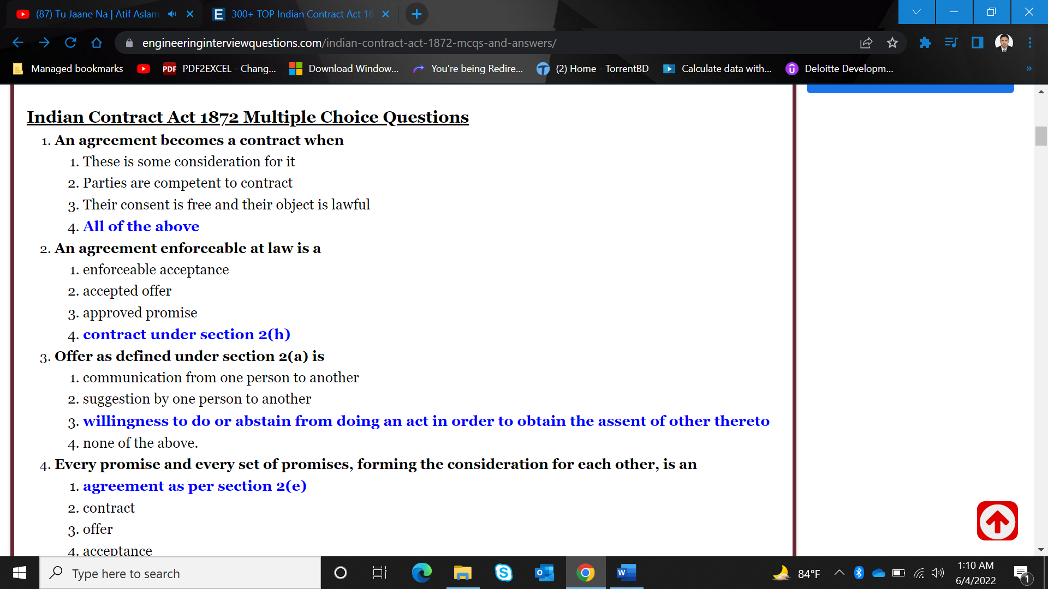 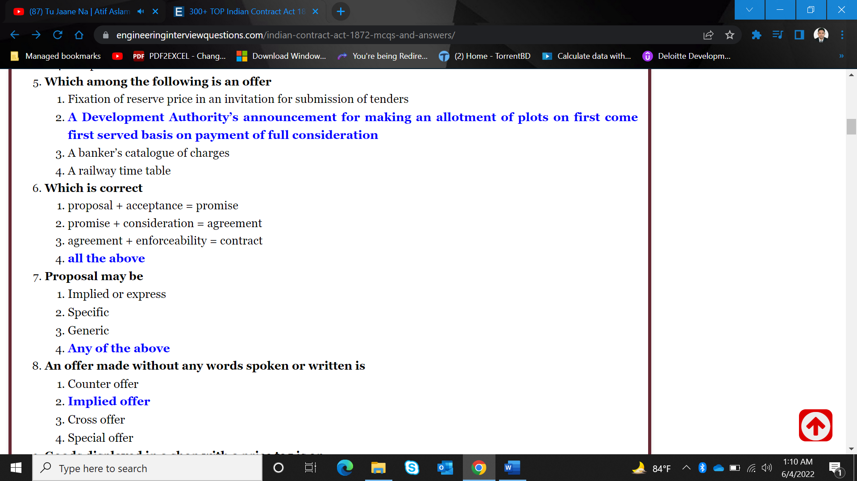 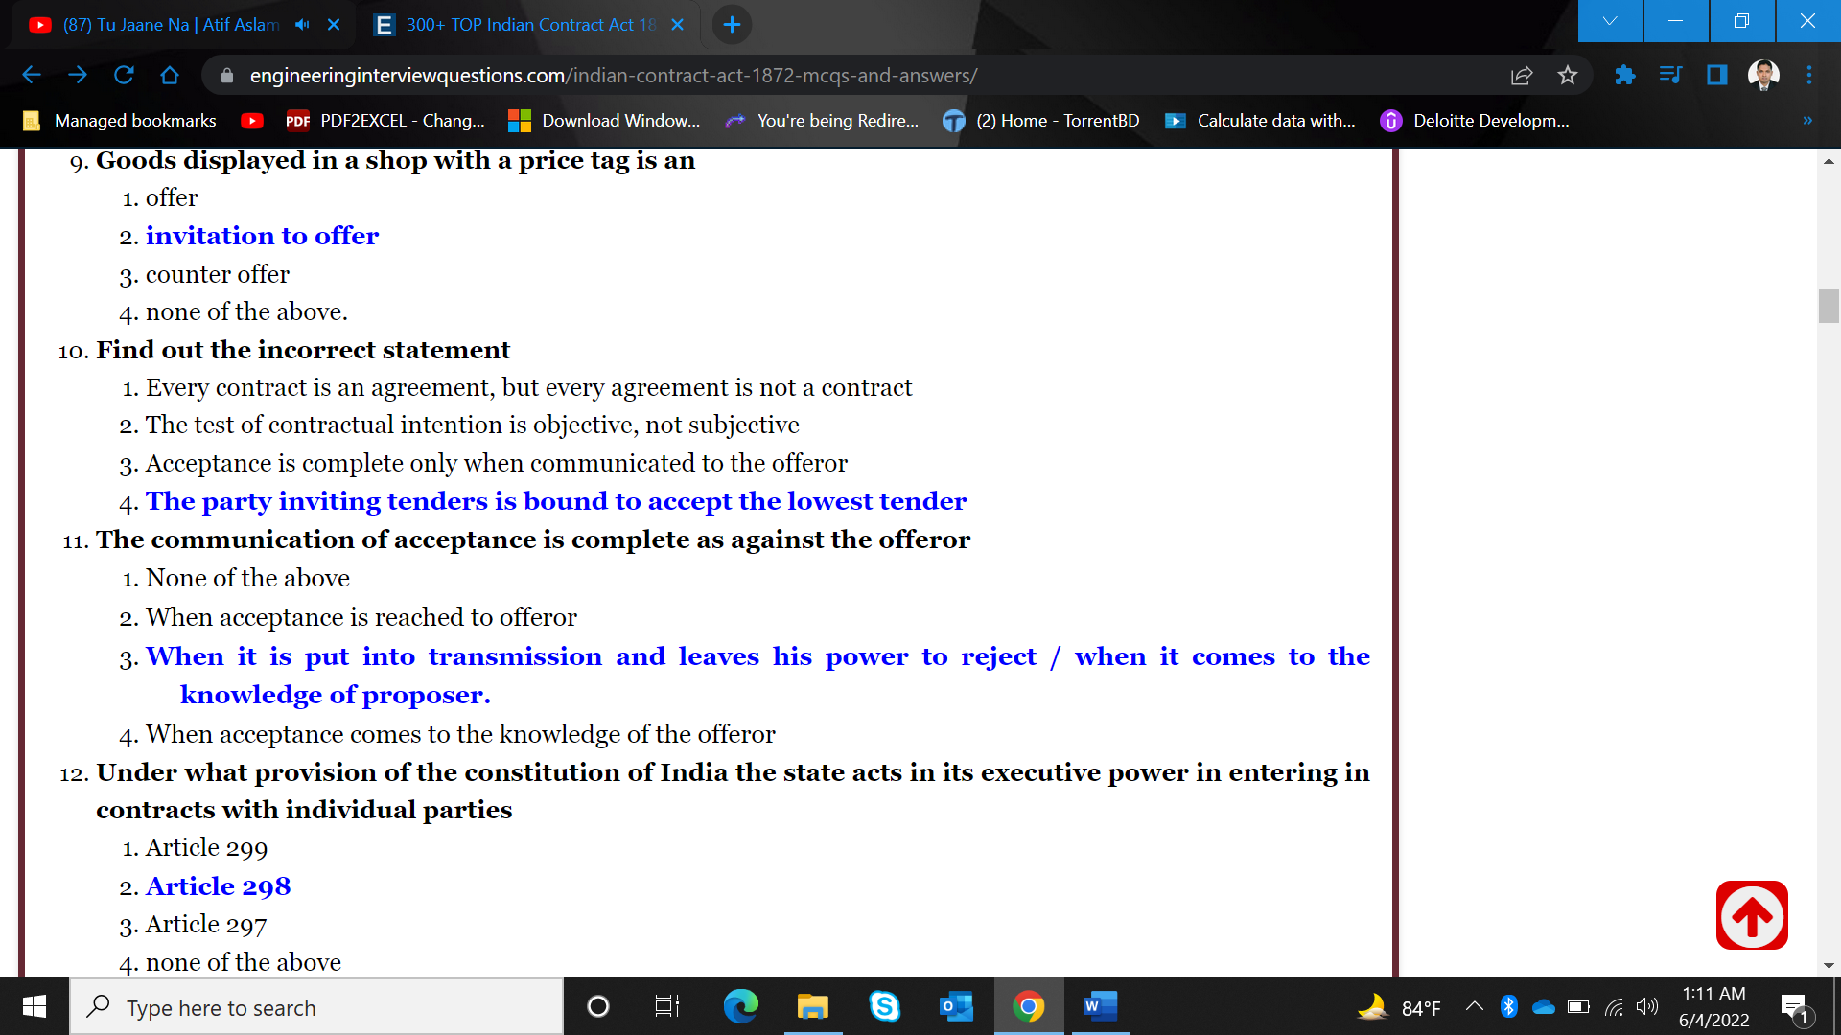 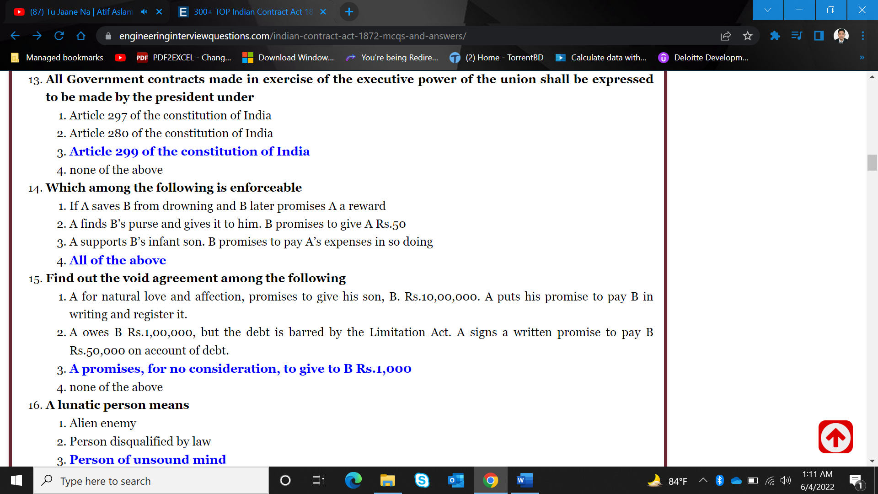 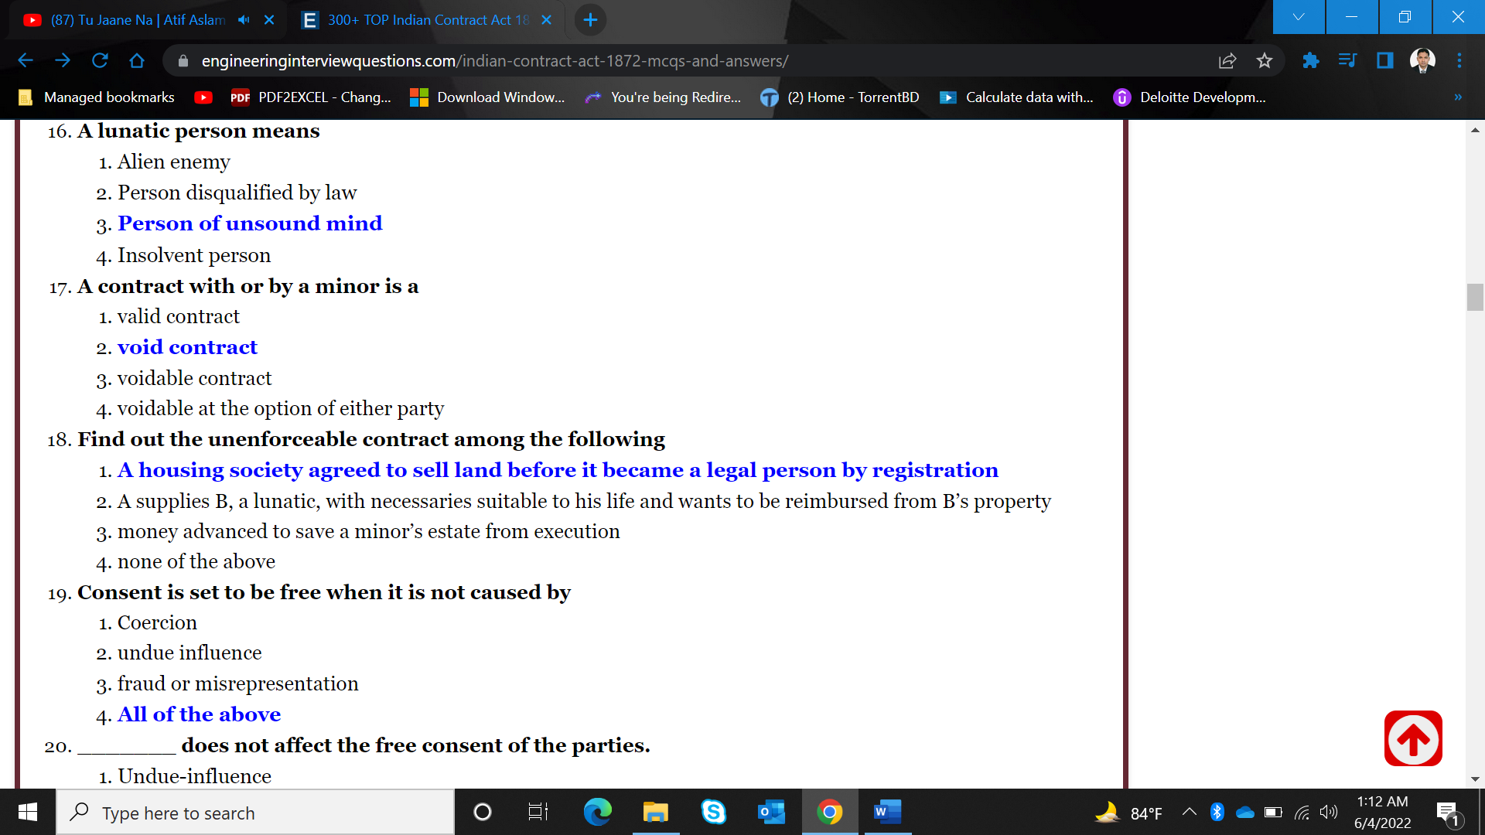 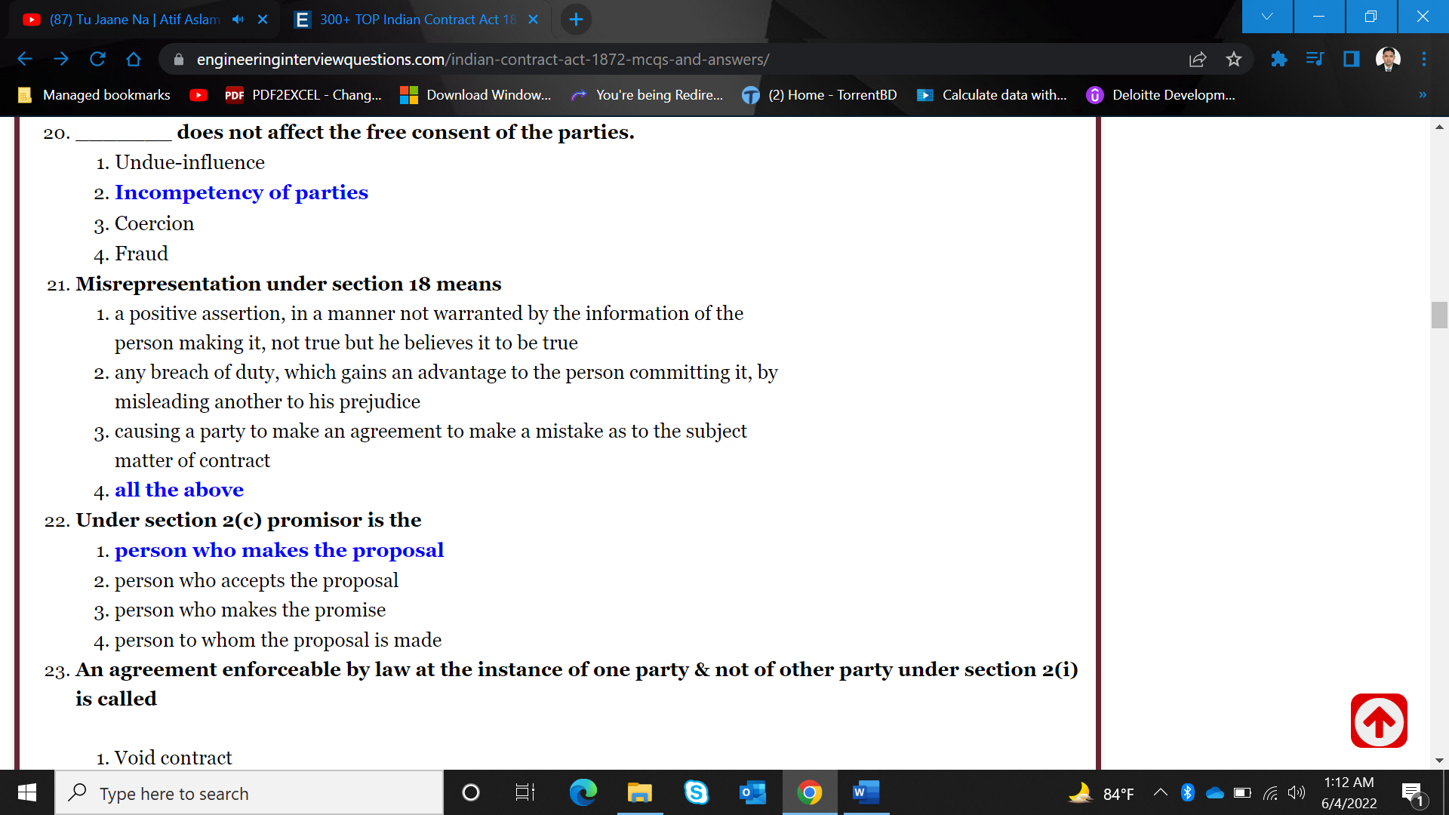 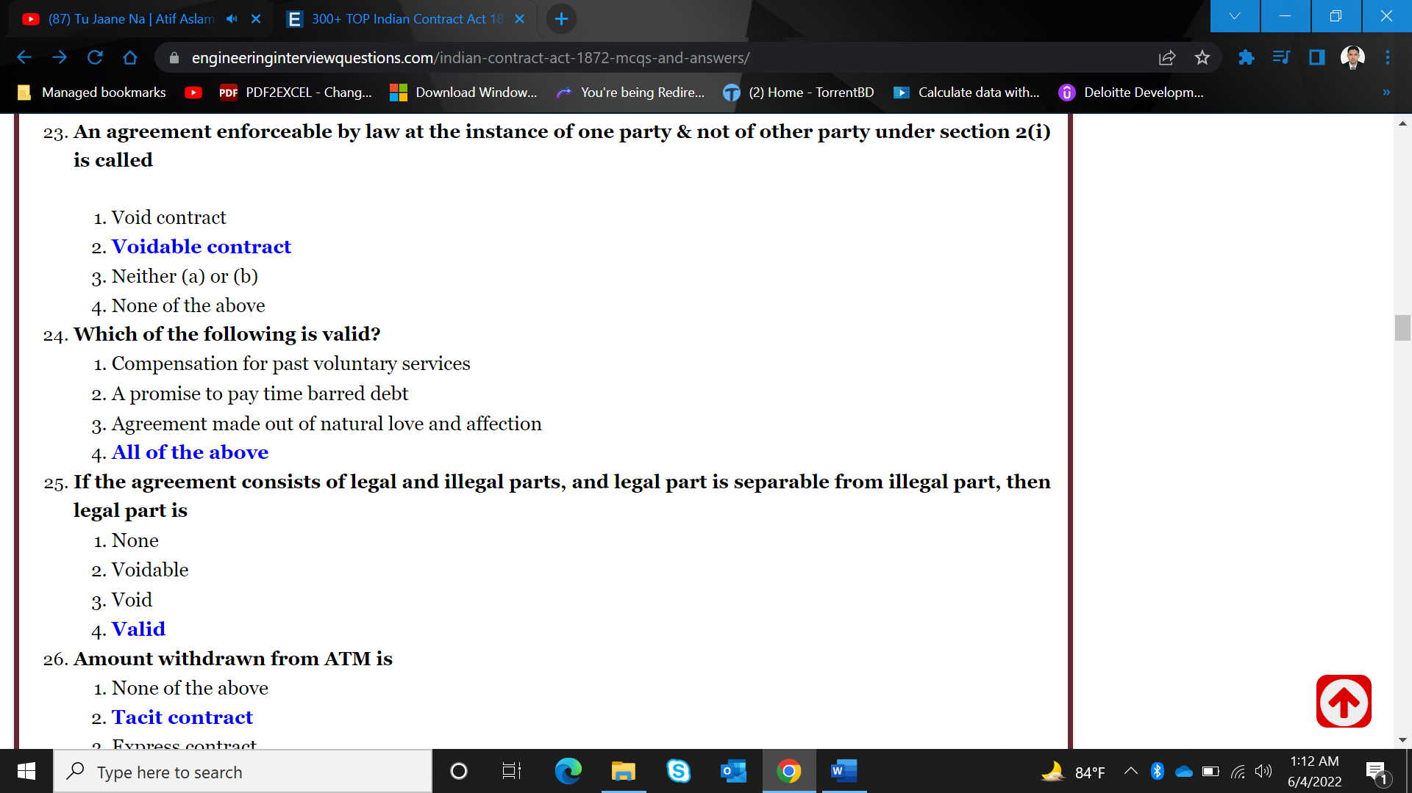 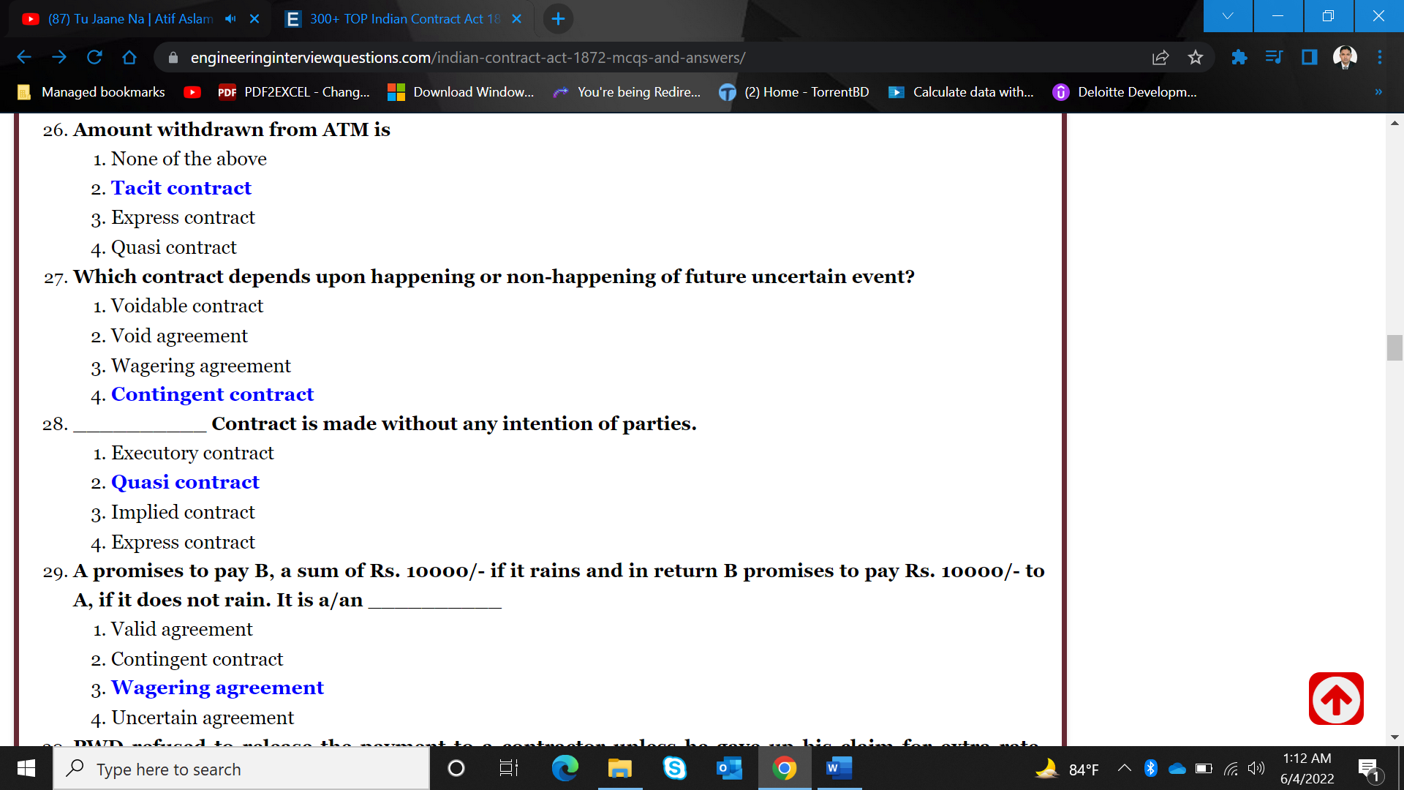 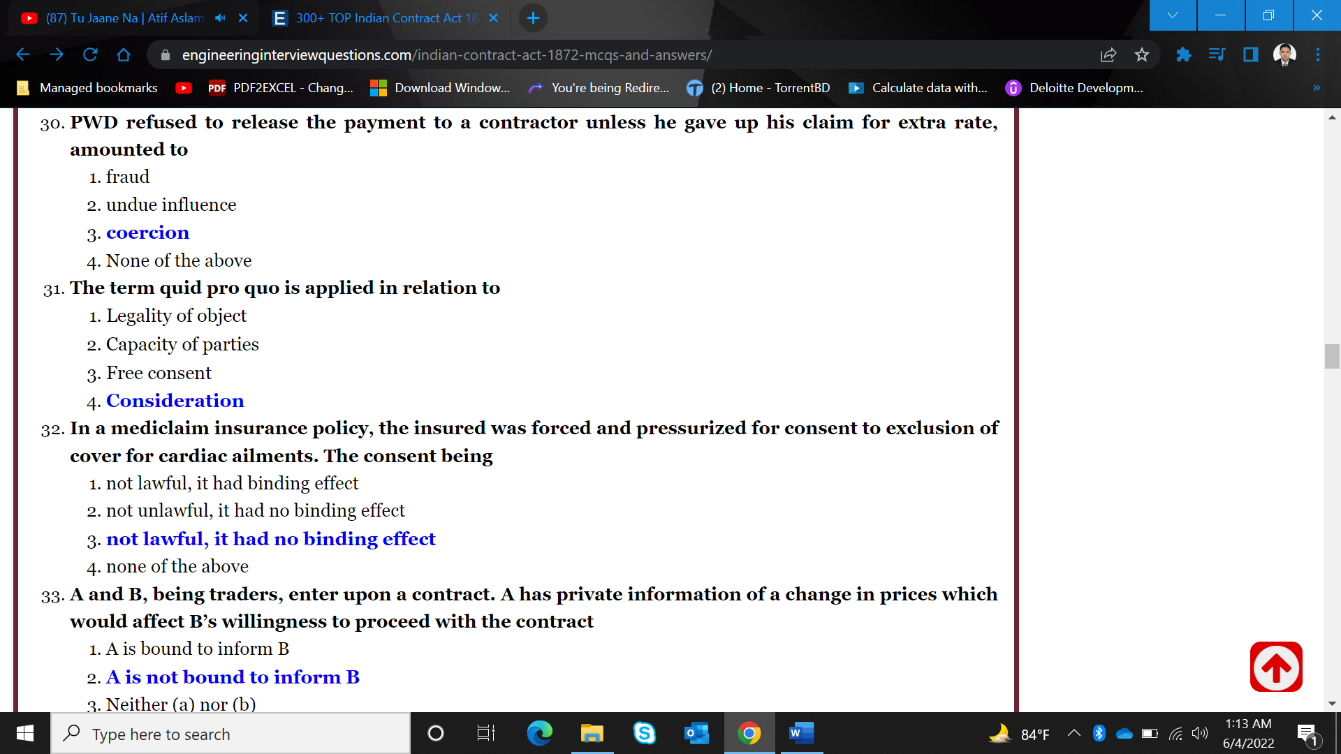 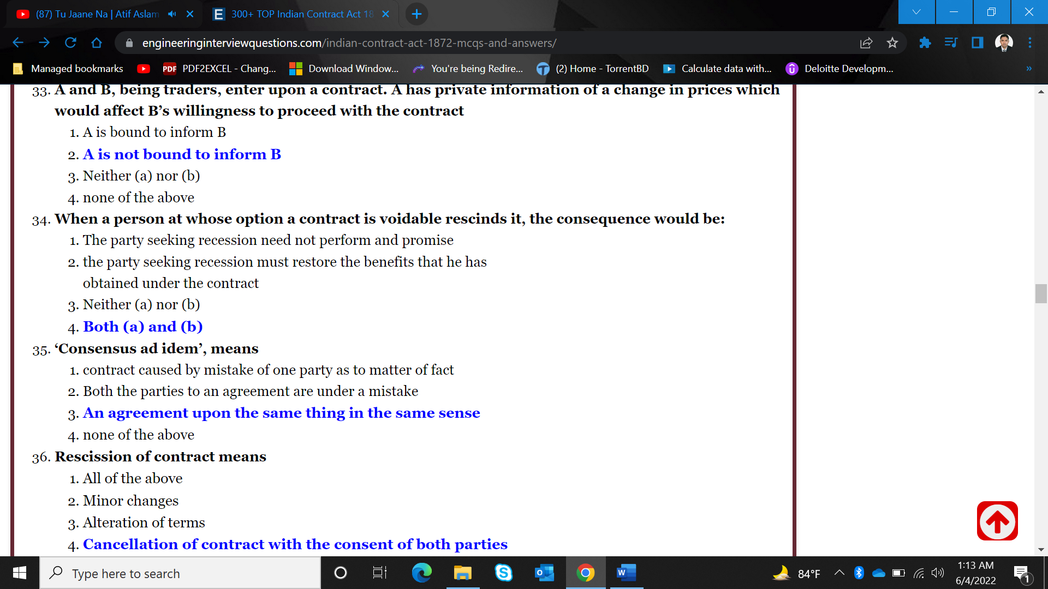 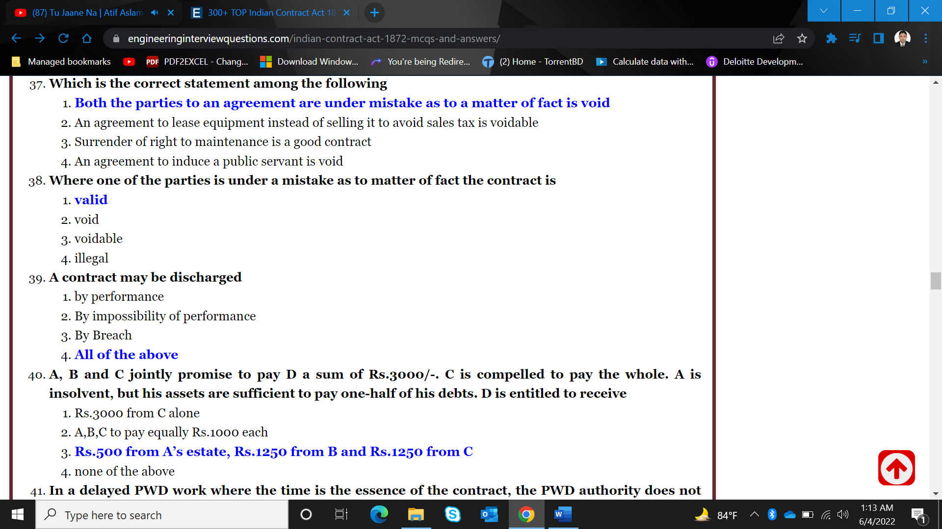 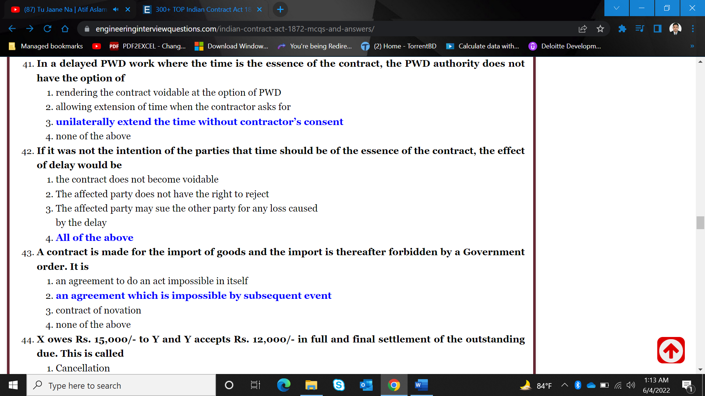 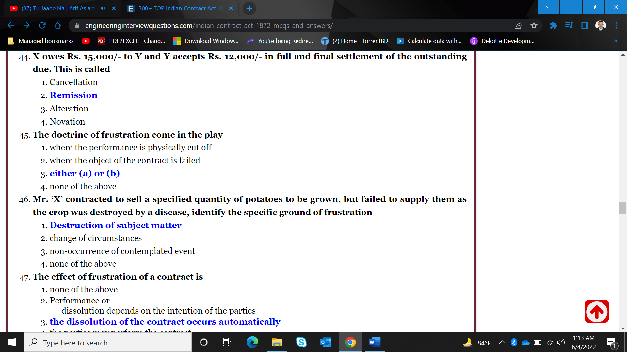 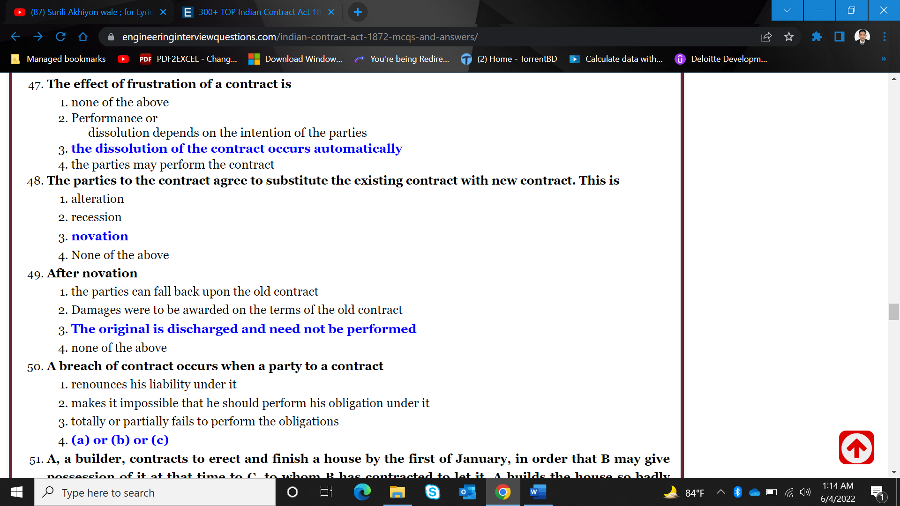 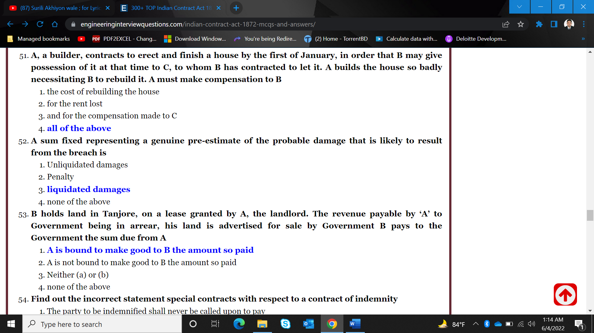 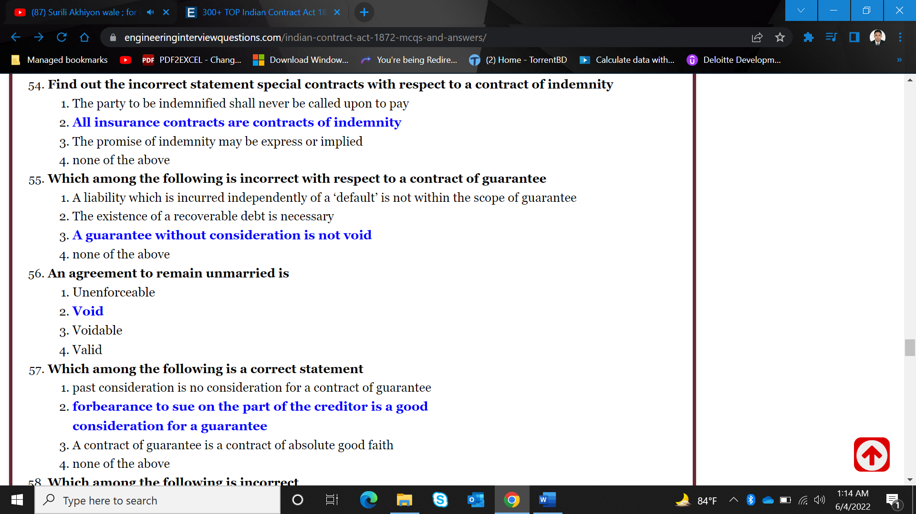 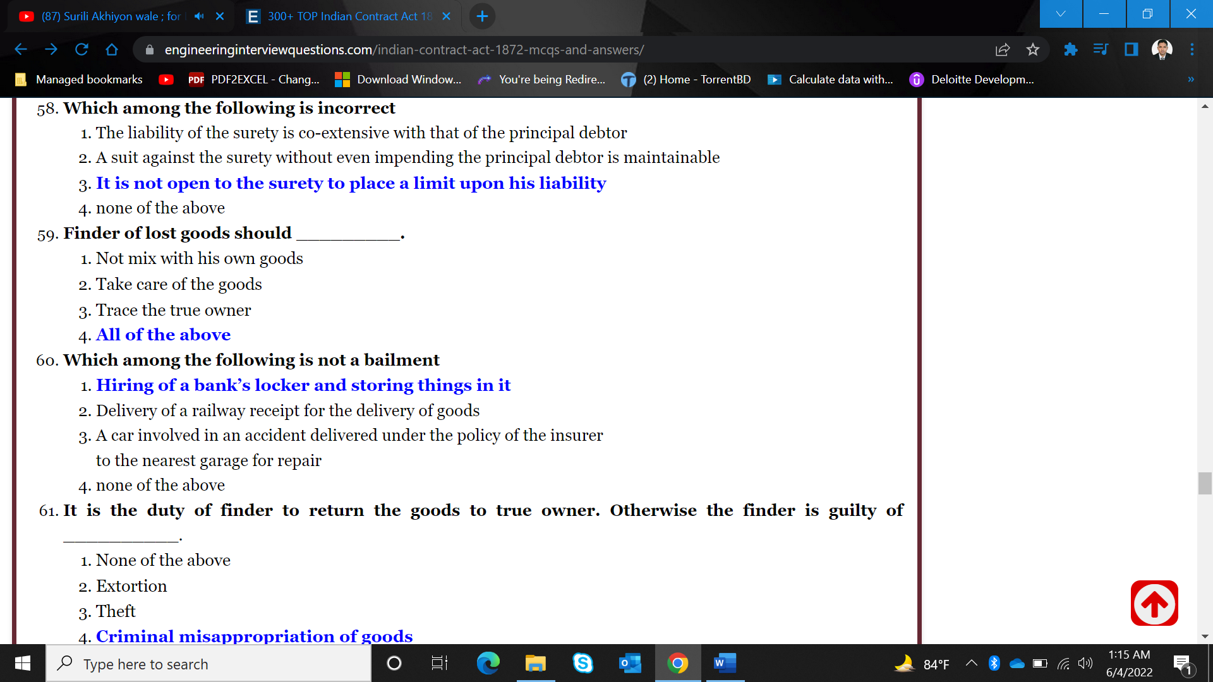 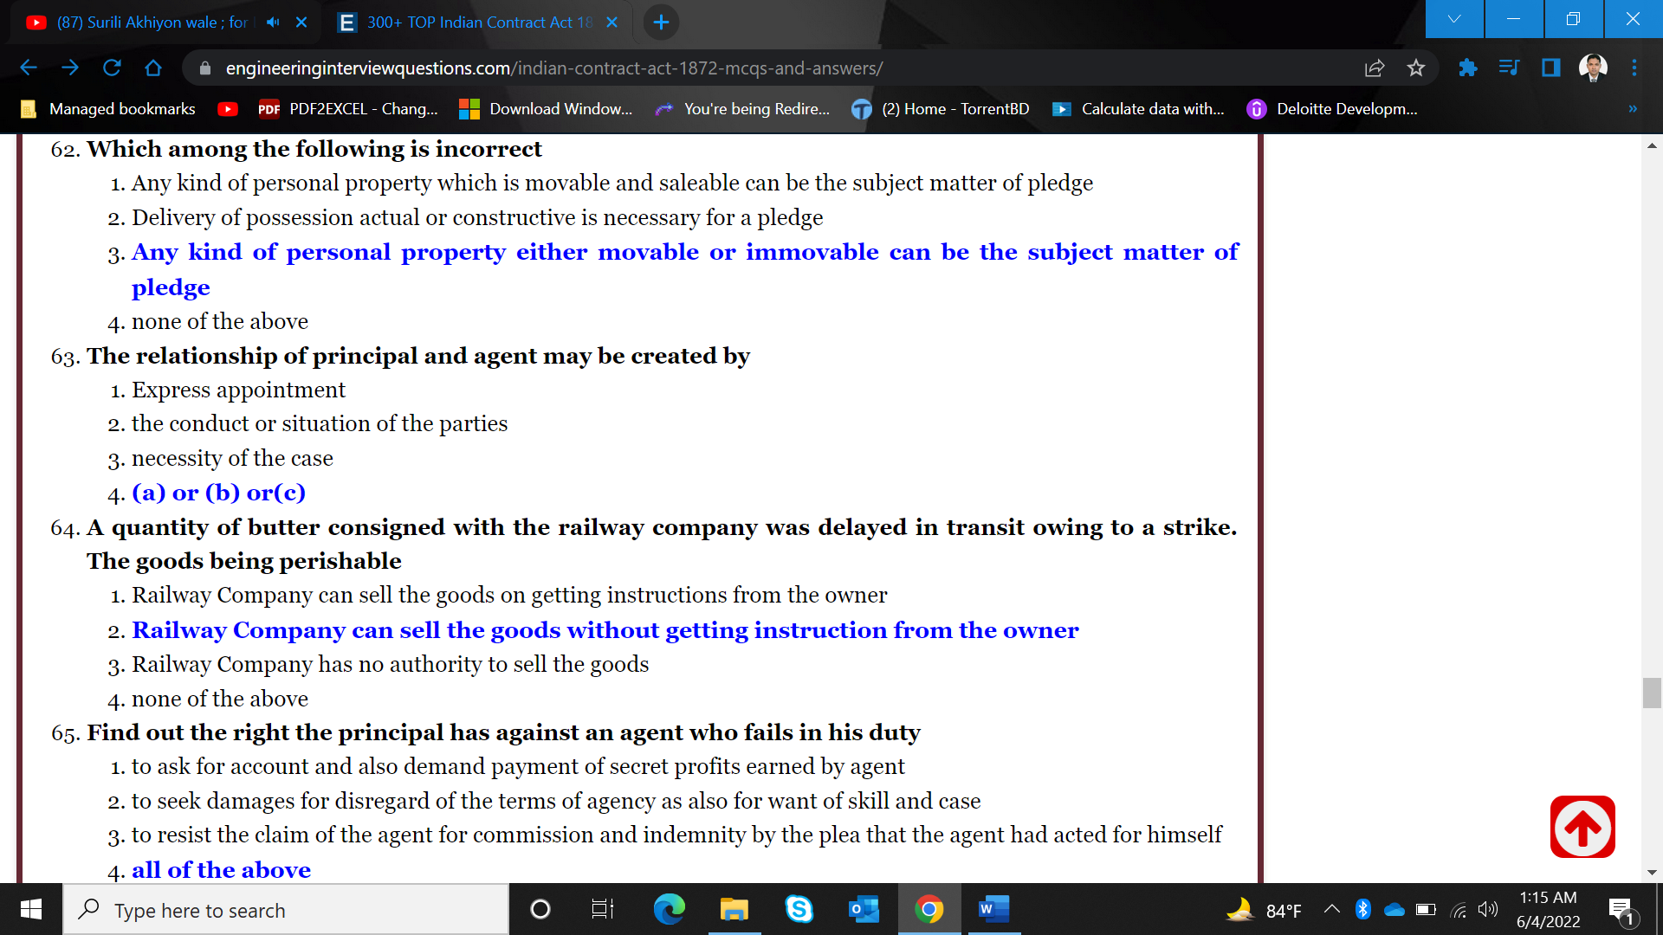 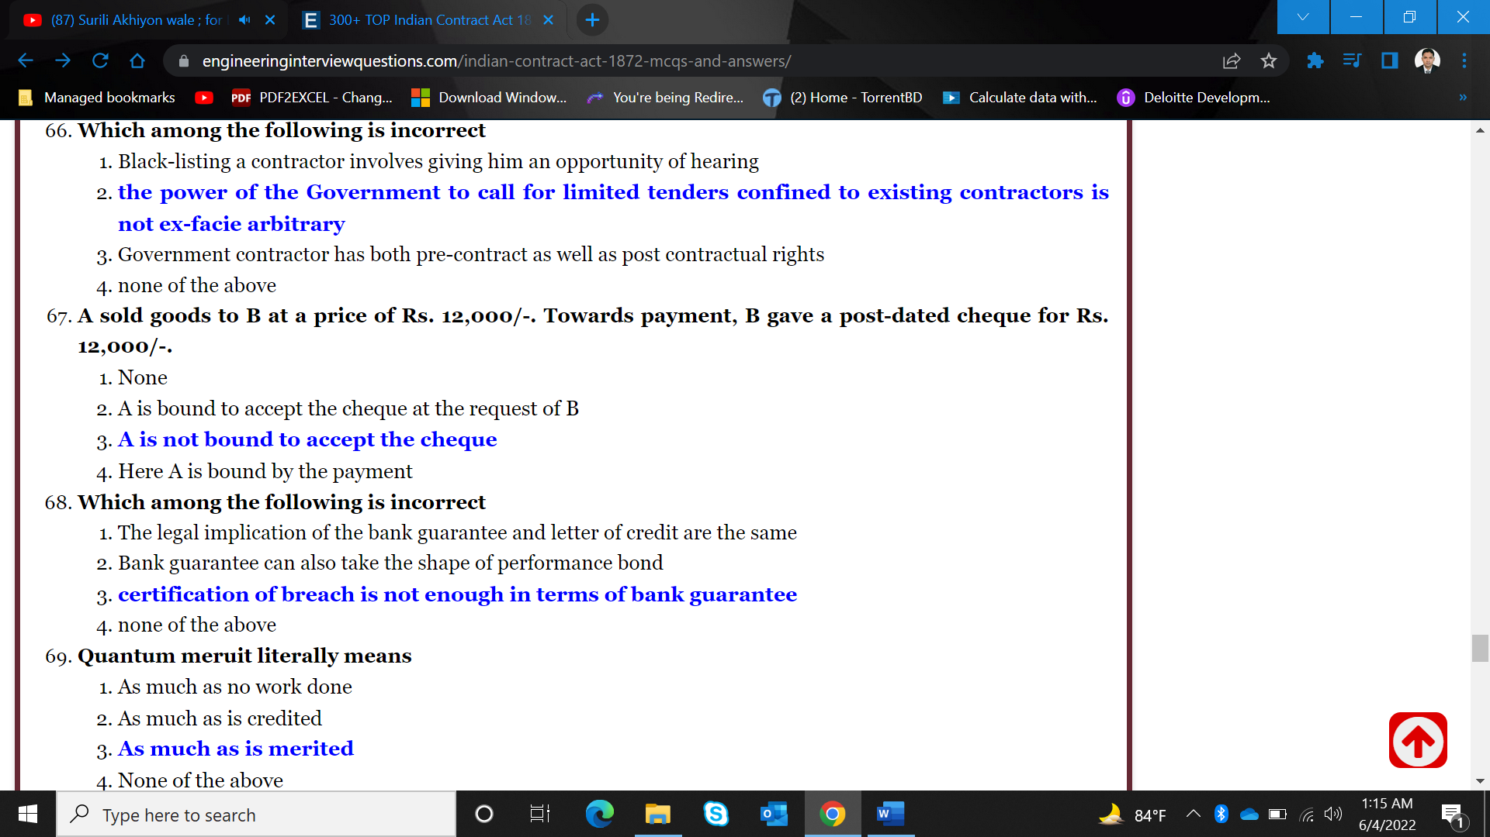 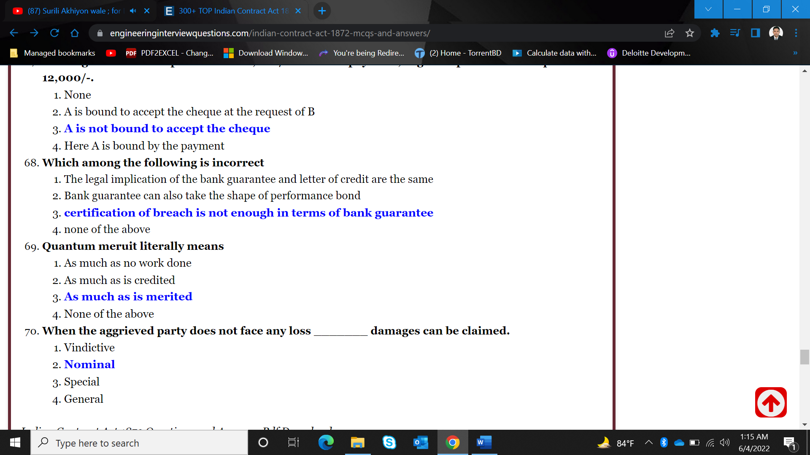

**MCQs on The Negotiable Instruments Act, 1881 Part 1**

**Q.1:- The Negotiable Instruments Act, 1881 is an Act to define and amend the law relating to:**

1. cheques
2. bills of exchange
3. promissory notes,
4. All of the above

Correct Option: D

**Q.2:- “banker” includes:**

1. Any person acting as an employee of any bank and any post office saving bank.
2. Any person acting as a banker and any post office saving bank
3. Any person acting as an agent of any bank and any post office saving bank.
4. Any person acting as a Managing Director of any bank and any post office saving bank

Correct Option: B

**Q.3:- Which is NOT an example of “Promissory Note”:**

1. “I acknowledge myself to be indebted to B in Rs. 1, 000, to be paid on demand, Tor value received.”
2. Mr B, I.O.U Rs. 1,000.”
3. “I promise to pay B or order Rs. 500”.
4. None of the above.

Correct Option: B

**Q.4:- In a Promissory Note, how many parties are involved:**

1. One
2. Two
3. Three
4. Four

Correct Option: B

**Q.5:- Which is NOT correct about the “Promissory Note”:**

1. It contains a conditional undertaking.
2. It contains the amount mentioned on it.
3. It is an instrument in writing.
4. It is signed by the maker

Correct Option: A

**Q.6:- The Negotiable Instruments Act, 1881 extends to:**

1. Only to Capital cities of the States.
2. The whole of India.
3. The whole of India except the State of Jammu and Kashmir.
4. The whole of India except the Union Territories.

Correct Option: B

**Q.7:- 8. Which is a “Promissory Note”**

1. I promise to pay B Rs. 500 and to deliver to him my black horse on 1st January next.
2. I promise to pay B Rs. 500 seven days /after my marriage with C .
3. “I acknowledge myself to be indebted to B in Rs. 1, 000, to be paid on demand, for value received.”
4. I promise to pay B Rs. 500 on D’s death, provided D leaves me enough to pay that sum.

Correct Option: C

**Q.8:- Section 5 of the NI Act deals with:**

1. Bills of Exchange
2. Holder in due course
3. Cheque
4. Promissory Note

Correct Option: A

**Q.9:- 20. A ‘Cheque’ is a Bills of exchange and has been defined under:**

1. The Negotiable Instruments Act, 1881
2. The General Clauses Act, 1897
3. The Reserve Bank of India Act, 1934
4. The Banking Regulation Act, 1949

Correct Option: A

**Q.10:- In an appeal by the drawer against conviction under section 138, the Appellate Court may order the appellant to deposit such sum which shall be a minimum of or compensation awarded by the trial Court:**

1. Ten per cent of the fine
2. Fifteen per cent of the fine
3. Twenty per cent of the fine
4. Twenty five per cent of the fine

Correct Option: C

**Q.11:- The interim compensation payable under section 143 A may be recovered as if it were a fine;**

1. As if it is a decree of a court
2. As per the provisions of Income Tax act, 1961
3. As per the provisions of the Code of Criminal Procedurc^l973.
4. None of the above

Correct Option: C

**Q.12:- All offences under Chapter XVII shall be tried by:**

1. A Metropolitan Magistrate
2. A Judicial Magistrate of the first class
3. Either A or B
4. None of the above

Correct Option: C

**Q.13:- Which court can entertain any offence punishable under section 138:**

1. Court not inferior to that of a Judicial Magistrate of the first class.
2. Any court having jurisdiction may entertain such case.
3. Court not inferior to that of a Metropolitan Magistrate.
4. D. Options A and C are correct.

Correct Option: D

**Q.14:- The liability of the drawer of a foreign bills of exchange is regulated in all essential matters by the law of the place where:**

1. he instrument has been negotiated
2. The instrument has been endorsed
3. The instrument is payable
4. The instrument is made.

Correct Option: D

**Q.15:- When a bill is said to be dishonoured:**

1. where presentment is excused and the bill is not accepted
2. one of several drawees makes default in acceptance upon being duly required to accept the bill.
3. by non-acceptance by the drawee
4. All of the above.

Correct Option: D

**Q.16:- What are the liabilities of a collecting banker:**

1. To serve notice of dishonour on the customer so that customer can claim the amount form his debtors.
2. To present cheque within a reasonable time else liable for damages.
3. To handover the proceeds after the realisation without delay.
4. All of the above.

Correct Option: D

**Q.17:- Where the holder of an instrument endorses it in a manner that does not incur any liability as an endorser, such endorsement is called as:**

1. Sans recourse Endorsement
2. Conditional endorsement
3. Facultative endorsement
4. Restrictive Endorsement

Correct Option: A

**Q.18:- A promissory note, bill of exchange or cheque payable to order, is negotiable:**

1. By endorsement and delivery thereof.
2. By the holder by endorsement
3. By delivery thereof.
4. None of the above.

Correct Option: A

**Q.19:- When the day on which a promissory note or bill of exchange is at maturity is a public holiday, the instrument shall be deemed to be due:**

1. On the same day.
2. On the next preceding business day.
3. On the next business day.
4. On the next succeeding business day.

Correct Option: B

**Q.20:- A negotiable instrument, dated 30th August, 2017, is made payable three months after date. What will be the maturity date:**

1. The instrument is at maturity on the 1 December, 2017.
2. The instrument is at maturity on the 2nd December, 2017.
3. The instrument is at maturity on the 3rd December, 2017.
4. The instrument is at maturity on the 4 December, 2017.

Correct Option: C

**Q.21:- Instrument entitled to ‘period of grace’ is:**

1. a bill or note payable on demand,
2. a cheque
3. a bill or note in which no time is mentioned.
4. a bill or note payable ‘after sight’,

Correct Option: D

**Q.22:- When a promissory note or bill of exchange are payable, in which no time for payment is specified:**

1. They are payable within 3 months
2. They are payable within 6 months.
3. They are payable on demand.
4. They are payable within a reasonable time.

Correct Option: C

**Q.23:- Where an instrument may be construed either as a promissory note or bill of exchange:**

1. A void instrument
2. A valid negotiable instrument
3. It is called as ambiguous instrument
4. It is called as unambiguous instrument

Correct Option: C

**Q.24:- When a promissory note, bill of exchange or cheque is transferred to any person, so as to constitute the person the holder thereof, the instrument is said to be:**

1. Mortgaged
2. Assigned
3. Negotiated
4. Pledged

Correct Option: C

**Q.25:- Which section of the NI Act defines the words, ‘Negotiable Instrument’:**

1. Section 15
2. Section 14
3. Section 13A
4. Section 13

Correct Option: D

**Q.26:- A promissory note, bill of exchange or cheque is payable__________which is expressed to be so payable or on which the only or last endorsement is an endorsement in blank.**

1. to order
2. to bearer
3. holder in due course
4. holder

Correct Option: B

**Q.27:- A promissory note, bill of exchange or cheque drawn or made out of India and made payable in, or drawn upon any person resident in India shall be deemed to be:**

1. Incomplete instrument
2. Inchoate instrument
3. Foreign instrument
4. Inland instrument

Correct Option: C

**Q.28:- A ‘Holder in due course’ of a Negotiable Instrument:**

1. Can sue on the instrument in his own name.
2. Can sue only if permitted by the competent court of law.
3. Can sue on the instrument if permitted by the payee.
4. Cannot sue on the instrument in his own name.

Correct Option: A

**Q.29:- Who is entitled at the time of loss or destruction of a note, bill or cheque:**

1. Drawee
2. Drawer
3. Holder.
4. Payee

Correct Option: C

**Q.30:- The “holder” of a promissory note, bill of exchange or cheque means:**

1. Any person entitled in his own name to the gos session thereof and to receive or recover the amount due thereon from the parties Thereto.
2. Any person entitled in his own name or his agent to the possession thereof and to receive or recover the amount due thereon from the parties thereto.
3. Any person having the possession of such instrument and to receive or recover the amount due thereon from the parties thereto.
4. Any person holding the physical custody of such instruments.

Correct Option: A

**Q.31:- The maker of a bill of exchange or cheque is called:**

1. The drawee
2. The payee
3. The drawer
4. The banker

Correct Option: C

**Q.32:- A cheque is a ............................drawn upon a specified banker and payable on demand:**

1. Bill of exchange
2. Hundi
3. Promissory note
4. None of the above

Correct Option: A

**Q.33:- What is NOT true about the “bills of exchange”:**

1. it is an instrument in writing
2. It is signed by the maker
3. Certain sum of money is mentioned on the instrument.
4. It contains a conditional order

Correct Option: D

**Q.34:- The definition of ‘Promissory Note’ has been defined in the NI Act in:**

1. Section 7
2. Section 6
3. Section 5
4. Section 4

Correct Option: D

**Q.35:- The NI Act, 1881 came into force with effect from:**

1. First day of April, 1882
2. First day of April, 1881
3. First day of March, 1882
4. First day of March, 1881

Correct Option: C

**Q.36:- A “promissory note” is an instrument to pay a certain sum of money:**

1. to the order of, a certain person, or to the bearer of the instrument,
2. To the bearer of the instrument.
3. To the order of, a certain person,
4. None of the above

Correct Option: A

**Q.37:- The nature of “promissory note” is:**

1. It contains an unconditional order to the drawee to pay the payee
2. It contains an unconditional promise by maker to pay the payee.
3. It is drawn on specified banker to pay on demand.
4. None of the above

Correct Option: B

**Q.38:- In case of “bills of exchange” ,**

1. the acceptance is:
2. It depends on the case to case basis Necessary if the bill is payable after sight.
3. Not necessary
4. None of the above.

Correct Option: B

**Q.39:- How many parties are there in the Bills of Exchange:**

1. Four
2. Three
3. Two
4. One

Correct Option: B

**Q.40:- What is NOT true about a cheque:**

1. It may contain a conditional order.
2. Cheque must be signed by the maker
3. The cheque must contain the date.
4. The amount must be specifically mentioned in figures and words.

Correct Option: A

**Q.41:- The person who is directed by the maker of a bill of exchange or cheque to pay is called the:**

1. Payee
2. Drawee
3. Endorsee
4. Drawer

Correct Option: B

**Q.42:- The person named in the instrument, to whom or to whose order the money is by the instrument directed to be paid, is called the:**

1. Banker
2. Drawee
3. Drawer
4. Payee.

Correct Option: D

**Q.43:- A Holder in due course is a person who becomes the possessor of the instrument.**

1. before maturity,
2. for consideration,
3. without any notice as to the defect in title of the Transferor
4. all of the above

Correct Option: D

**Q.44:- Inland instrument means:**

1. A promissory note, bill of exchange or cheque drawn or made in India and made payable in or drawn upon any person resident in, India shall be deemed to be an inland instrument.
2. A promissory note, bill of exchange or cheque drawn or made in India and made payable in or drawn upon any person resident outside India shall be deemed to be an inland instrument.
3. A promissory note, bill of exchange or cheque drawn or made outside India and made payable in, or drawn upon any person resident in, India shall be deemed to be an inland instrument.
4. None of the above.

Correct Option: A

**Q.45:- A “negotiable instrument” means:**

1. cheque payable either to order or to bearer.
2. bill of exchange
3. a promissory note
4. all the options are correct.

Correct Option: D

**Q.46:- Whether a negotiable instrument may be made payable:**

1. In the alternative to one of two,
2. To one or some of several payees.
3. To two or more payees jointly,
4. All the options are correct.

Correct Option: D

**Q.47:- Which among the following is a negotiable instrument:**

1. Banker’s Demand Draft
2. Currency note
3. Letter of Credit
4. Letter of guarantee

Correct Option: A

**Q.48:- Where the endorser signs his name on the back of the instrument only, the endorsement is said to be:**

1. In full
2. In blank
3. Facultative endorsement
4. Conditional endorsement

Correct Option: B

**Q.49:- Not with standing anything contained in the Code of Criminal Procedure, 1973 (2 of 1974), every offence punishable under the NI Act shall be:**

1. Non-compoundable
2. "Compoundable''
3. Non-bailable
4. Bailable

Correct Option: B

**Q.50:- The interim- compensation shall be paid within................. from the date of the order or within such further period not exceeding thirty days as may be directed by the Court on sufficient cause being shown by the drawer of the cheque:**

1. Sixty days
2. Fifty days
3. Forty days
4. Thirty days

Correct Option: A

**MCQs on The Negotiable Instruments Act, 1881 Part 2**

**Q.1:- the Court trying an offence under section 138 may order the drawer of the cheque to pay interim compensation to the complainant, which shall:**

1. Not exceed ten per cent of the amount of the cheque
2. Not exceed fifteen per cent of the amount of the cheque
3. Not exceed twenty per cent of the amount of the cheque
4. Not exceed twenty five per cent of the amount of the cheque

Correct Option: C

**Q.2:- In the case of any conviction in a summary trial under section 143, it shall be lawful for the Magistrate to pass a sentence of imprisonment for a term:**

1. not exceeding two year and an amount of fine exceeding five thousand rupees.
2. not exceeding one year and an amount of fine exceeding five thousand rupees:
3. not exceeding six month and an amount of fine exceeding five thousand rupees:
4. not exceeding one month and an amount of fine exceeding five thousand rupees.

Correct Option: B

**Q.3:- With respect to multicity cheque dishonor the offence under section 138 shall be inquired into and tried only by a court within whose local jurisdiction:**

1. if the cheque is presented for payment by the payee or holder in due course, otherwise through an account, the branch of the drawee bank where the drawer maintains the account, is situated.
2. if the cheque is delivered for collection through an account, the branch of the bank where the payee or holder in due course, as the case may be, maintains the account, is situated.
3. Both the options A and B are correct.
4. None of the above.

Correct Option: C

**Q.4:- Notwithstanding anything contained in the Code of Criminal Procedure, 1973 no court shall take cognizance of any offence punishable under section 138 except upon a complaint, in writing, made by the payee or, as the case may be, the holder in due course of the cheque and such complaint is made of the date on which the cause of action arises under clause(c) of the proviso to section 138:**

1. Within three months
2. Within two months
3. Within one month
4. Within fifteen day

Correct Option: C

**Q.5:- For invoking section 138 of NI Act, the payee or the holder in due course of the cheque, as the case may be, shall have to make a demand for the payment of the said amount of money by giving a notice, in writing, to the drawer of the cheque, of the receipt of information by him from the bank regarding the return of the cheque as unpaid:**

1. Within five days
2. Within ten day
3. Within fifteen days
4. Within twenty days.

Correct Option: C

**Q.6:- What are the conditions for availing statutory protections available to a banker under section 131:**

1. The payment is received for a customer of the Bank.
2. Cheque is crossed generally or specially before it is presented to the paying bank.
3. Banker has in good faith and without negligence received payment.
4. All of the above.

Correct Option: D

**Q.7:- The protection to paying bank for crossed cheque is covered under which section of N I Act:**

1. Section 138
2. Sectionl31
3. Section 128
4. Section 85

Correct Option: C

**Q.8:- Section 118 of the N I Act deals with the presumptions as to negotiable instruments until the contrary is proved. Which among the following is NOT such presumption:**

1. As to stamps-that a lost promissory note, bill of exchange or cheque was not duly stamped.
2. As to date-that every negotiable instrument bearing a date was made or drawn on such date.
3. As to time of acceptance-that every accepted bill of exchange was accepted within a reasonable time after its date and before its maturity.
4. As to time of transfer-that every transfer of a negotiable instrument was made before its maturity

Correct Option: A

**Q.9:- When no rate of interest is specified in the instrument, interest on the amount due thereon shall, notwithstanding any agreement relating to interest between any parties to the instrument, be calculated from the date at which the same ought to have been paid by the party charged, until tender or realization of the amount due thereon, or until such date after the institution of a suit to recover such amount as the Court directs:**

1. at the rate of six per centum per annum
2. at the rate of twelve per centum per annum
3. at the rate of eighteen per centum per annum
4. at the rate of twenty four per centum per annum

Correct Option: C

**Q.10:- What is the liability of a banker when a cheque has been materially altered but does not appear to have been so altered, and payment thereof has been made according to the apparent tenor thereof at the time of payment and otherwise in due course:**

1. The Banker shall be liable to make good the loss suffered by the customer.
2. The Banker shall discharge from all liability thereon, and such payment shall not be questioned by reason of the instrument having been altered.
3. The concerned official of the bank will be charge sheeted.
4. The Banker shall be liable for such wrong payment of the cheque which has been so altered.

Correct Option: B

**Q.11:- Under which section a paying banker is protected where a cheque payable to order purports to be endorsed by or on behalf of the payee, the drawee bank is discharged by payment in due course:**

1. Section 131
2. Section 86
3. Section 85A
4. Section 85

Correct Option: D

**Q.12:- Who can make negotiation of a negotiable instrument:Which is not the right of a holder:**

1. All of several joint makers, drawers, payees or indorsees.
2. Sole maker, drawer, payee or indorsee.
3. Both A and B are correct.
4. None of the above.

Correct Option: C

**Q.13:- Where an endorsement by express words, restrict or exclude the right of further negotiability of the instrument, it is called:**

1. Blank endorsement
2. Partial endorsement
3. Conditional endorsement
4. Restrictive endorsement

Correct Option: D

**Q.14:- The drawee of a cheque having sufficient funds of the drawer in his hands properly applicable to the payment of such cheque must pay the cheque when duly required so to do, and, in default of such payment, must compensate the drawer for any loss or damage caused by such default. This is governed by which section of the N I Act:**

1. Section 131
2. Section 85
3. Section 31
4. Section 30

Correct Option: C

**Q.15:- A promissory note or bill of exchange, dated 31st August, 2017 is made payable three months after date. What will be the maturity date:**

1. The instrument is at maturity on the
2. The instrument is at maturity on the 1 December, 2017.
3. The instrument is at maturity on the 2 December, 2017.
4. The instrument is at maturity on the 3rd December, 2017.

Correct Option: D

**Q.16:- A negotiable instrument dated 29 January, 2018, is made payable at one month after date. What will be its maturity date:**

1. The instrument is at maturity on the 28 February, 2018.
2. The instrument is at maturity on the second day after the 28th February, 2018.
3. The instrument is at maturity on the third day after the 28 February, 2018.
4. The instrument is at maturity on the fourth day after the 28 February, 2018.

Correct Option: C

**Q.17:- The days of grace of maturity of promissory note or bill of exchange is:**

1. A. The maturity day after the day on which it is expressed to be payable.
2. B. The second day after the day on which it is expressed to be payable.
3. C. The third day after the day on which it is expressed to be payable.
4. D. The fourth day after the day on which it is expressed to be payable.

Correct Option: C

**Q.18:- Where one person signs and delivers to another a paper stamped in accordance with the law relating to negotiable instruments then in force in India, and either wholly blank or having written thereon an incomplete negotiable instrument, he thereby gives prima facie authority to the holder thereof to make or complete, as the case may be, upon it a negotiable instrument, for any amount specified therein and not exceeding the amount covered by the stamp. What is this called under the N.I. Act:**

1. Complete instrument
2. Indorsement
3. Inchoate stamped instrument
4. None of the above.

Correct Option: C

**Q.19:- Where the amount mentioned on the cheque differs in words and figures, which amount should be considered:**

1. The amount stated in figures.
2. The amount stated in words1
3. Both A and B the options are not correct and cheque is required to be returned.
4. It depends upon the discretion of the banker.

Correct Option: B

**Q.20:- When the maker or holder of a negotiable instrument signs the same, otherwise than as such maker, for the purpose of negotiation, on the back or face thereof or on a slip of paper annexed thereto, or so signs for the same purpose a stamped paper intended to be completed as a negotiable instrument, he is said to indorse the same. This activity is called as:**

1. Selling of instrument
2. Endorsement
3. Transfer of instrument
4. None of the above.

Correct Option: B

**Q.21:- Who is called as Drawee in case of need:**

1. When the bill or in any endorsement thereon the name of any person is given in addition to the drawee to be resorted to in case of need, such person is called a “drawee in case of need”.
2. When the bill or in any endorsement thereon the name of any person is given is called a “drawee in case of need”.
3. When the drawee have the need of the bills of exchange.
4. When the bill or in any endorsement thereon the names of more than one person is given in addition to the drawee to be resorted to in case of need, such person is called a “drawee in case of need”.

Correct Option: A

**Q.22:- Define Cheque:**

1. A “cheque” is a bill of exchange drawn on any banker and not expressed to be payable otherwise than on demand and it includes the electronic image of a truncated cheque and a cheque in the electronic form.
2. A “cheque” is a bill of exchange and expressed to be payable otherwise than on demand and it includes the electronic image of a truncated cheque and a cheque in the electronic form.
3. A “cheque” is a bill of exchange drawn on a specified banker and not expressed to be payable otherwise than on demand and it includes the electronic image of a truncated cheque and a cheque in the electronic form.
4. A “cheque” is a bill of exchange drawn on a specified banker and it includes the electronic image of a truncated cheque and a cheque in the electronic form.

Correct Option: C

**Q.23:- What is ‘bills of exchange’:**

1. A “bill of exchange” is an instrument in writing containing an unconditional order, signed by the maker, directing a certain person to pay a certain sum of money only to, or to the order of, a certain person or to the bearer of the instrument.
2. A “bill of exchange” is an instrument in writing containing an unconditional order, signed by the maker, directing any person to pay a certain sum of money only to, or to the order of, a certain person or to the bearer of the instrument.
3. A “bill of exchange” is an instrument in writing containing a conditional order, signed by the maker, directing a certain person to pay a certain sum of money only to, or to the order of, a certain person or to the bearer of the instrument.
4. A “bill of exchange” is an instrument containing an unconditional order, signed by the maker, directing a certain person to pay a certain sum of money only to, or to the order of, a certain person or to the bearer of the instrument.

Correct Option: A

**Q.24:- A promissory note, bill of exchange or cheque payable to bearer is negotiable:**

1. By blank indorsement
2. By indorsement
3. By delivery thereof
4. By restrictive indorsement

Correct Option: C

**MCQs On Indian Partnership Act, 1932 Part 1**

**Q.1:- An act of a firm means:**

1. Any partner or agent of the firm which gives rise to a right enforceable by or against the firm
2. Any act by all the partners
3. Any omission by all the partners
4. All of the above

Correct Option: D

**Q.2:- Partnership is the relation between persons who have agreed to share the profits of a business carried on by all or any of them acting for all. Does it mean that losses are not shared:**

1. A minor may be admitted in partnership, only for the profits, but he cannot share in losses.
2. It also depends on the partnership agreement. A person may share the profits but may not share in losses.
3. Sharing of profits also include losses (negative profits)
4. All of the above.

Correct Option: D

**Q.3:- Where no provision is made by contract between the partners for the duration of their partnership, or for the determination of their partnership, the partnership is called as:**

1. Particular partnership
2. Partnership for a fixed term
3. partnership at will
4. None of the above

Correct Option: C

**Q.4:- What information shall be given to the Registrar of Firms by a registered partnership firm:**

1. New opening/closing of the existing branch, if any.
2. Change in the name of and address of the partner (s)/change in the constitution of the firm.
3. What there is change in the name of the firm or in location of the principal place of business.
4. All of the above.

Correct Option: D

**Q.5:- Who can inspect the Register and filed documents at the office of the Registrar:**

1. Any Government servant
2. The Partners of the firm
3. The partners of the other firms
4. Any person

Correct Option: D

**Q.6:- What are the right of partners after dissolution:**

1. To have the surplus distributed among the partners or their representatives according to their rights.
2. To have business wound up after dissolution
3. To have the property of the firm applied in payment of the debts and liabilities of the firm.
4. All of the above

Correct Option: D

**Q.7:- 40. Where any member of a firm has died or otherwise ceased to be a partner, and the surviving or continuing partners carry on the business of the firm with the property of the firm without any final settlement of accounts as between them and the outgoing partner or his estate, then, in the absence of a contract to the contrary, the outgoing partner or his estate is entitled at the option of himself or his representatives to such share of the profits made since he ceased to be a partner as may be attributable to the use of his share of the property of the firm or to interest at the rate of on the amount of his share in the property of the firm:**

1. nine per cent, per annum
2. eighteen per cent, per annum
3. six per cent per annum
4. twelve per cent, per annum

Correct Option: C

**Q.8:- The dissolution of partnership means:**

1. It means the dissolution of partnership between all the partners of a firm
2. It means the change in the relations of the partners
3. It means the reconstitution of the firm.
4. None of the above.

Correct Option: B

**Q.9:- In what circumstances a partner may retire:**

1. In accordance with an express agreement by the partners
2. Where the partnership is at will, by giving notice in writing to all the other partners of his intention to retire.
3. With the consent of all the other partners
4. All of the above.

Correct Option: D

**Q.10:- What would be the position, where a minor elects not to become a partner:**

1. He shall be entitled to sue the partners for his share of the property and profits.
2. His rights and liabilities shall continue to be those of a minor under this section up to the date on which he gives public notice.
3. His share shall not be liable for any acts of the firm done after the date of the notice.
4. All of the above

Correct Option: D

**Q.11:- After a partner’s death the business is continued in the old firm name. Whether the legal heirs of the deceased partner are liable for any acts of the firm:**

1. The continued use of the name or of the deceased partner’s name as a part thereof shall not of itself make his legal representative or his estate liable for any act of the firm done after his death.
2. If the estate of the deceased person’s property is insufficient to make good, the personal assets of the legal heirs will be liable for any of the acts done by the firm.
3. The estate of the deceased person is liable for any of the act done by the firm.
4. The legal heirs of the deceased partners shall be liable for any of the act done by the firm after the demise of the partner

Correct Option: A

**Q.12:- The partners in a firm may, by contract between the partners:**

1. restrict the implied authority of any partner
2. extend the implied authority of any partner
3. None of the above
4. Both A and B are correct

Correct Option: D

**Q.13:- Whether a notice given to a partner, who habitually acts in the business of the firm of any matter relating to the affairs of the firm, will be deemed as notice to the firm:**

1. It will deemed as personal information to that partner
2. Yes, it operates as notice to the firm, except in the case of a fraud on the firm committed by or with the consent of that partner
3. It depends on the nature of the concerned partner whether he inform so to other partners
4. No, it will not deemed as notice to the firm.

Correct Option: B

**Q.14:- What would be the position where a minor elects to become a partner.**

1. His share in the property and profits of the firm shall be the share to which he was entitled as a minor
2. His rights and liabilities as a minor continue up to the date on which he becomes a partner
3. He also becomes personally liable to third parties for all acts of the firm done since he was admitted to the benefits of partnership
4. All of the above

Correct Option: D

**Q.15:- When there is any change in the constitution of the firm, what would be the statue of the continuing guarantee given to the firm**

1. It shall be revoked as to future transactions from the date of any change in the constitution of the firm.
2. Since it is the continuing guarantee, hence it be continuing.
3. Only the parties to the continuing guarantee can only decide over the matter.
4. None of the above.

Correct Option: A

**Q.16:- Where a partner wilfully or persistently commits breach of agreements relating to the management of the affairs of the firm or the conduct of its business, or otherwise so conducts himself in matters relating to the business that it is not reasonably practicable for the other partners to carry on the business in partnership with him. The other partner(s) may:**

1. The partnership firm comes to an end automatically
2. The other partners may decide to leave the firm.
3. File a suit in the court for the dissolution of the firm.
4. The other partners may decide to expel the concerned partner

Correct Option: C

**Q.17:- Who is not liable for the acts of the partners done after dissolution, if done before the dissolution, until public notice is given of the dissolution**

1. A partner who, not having been known to the person dealing with the firm to be a partner, retires from the firm (sleeping or dormant partner).
2. The estate of a partner who dies
3. Who is adjudicated an insolvent
4. All of the above

Correct Option: D

**Q.18:- Where a partner has paid a premium on entering into partnership of a fixed term, and the firm is dissolved before the expiration of that term otherwise than by the death of a partner, whether any repayment of the premium is permissible:**

1. He will not be entitled for repayment of the premium if the dissolution is mainly due to his own misconduct
2. He will not be entitled for repayment of the premium if the dissolution is in pursuance of an agreement containing no provision for the return of the premium or any part of it
3. He shall be entitled to repayment of the premium or of such part thereof as may be reasonable, regard being had to the terms upon which he became a partner and to the length of time during which he wasa partner
4. All of the above

Correct Option: D

**Q.19:- Whether a partner after dissolution of the partnership firm, carry on the business in the erstwhile business name of the firm**

1. He can use the business name of the dissolved firm name, if he has brought the goodwill of the firm.
2. He can’t use the business name of the dissolved firm.
3. He can use the business name of the dissolved firm, provided there was a contract between the partners of the dissolved firm
4. Both the points mentioned at A and C are correct

Correct Option: D

**Q.20:- The State Government may appoint Registrars of Firms for the purposes of this Act, every Registrar shall be deemed**

1. To be a Central Government Servant.
2. To be a public servant within the meaning of section 21 of the Indian Penal Code
3. To be State Government Servant
4. To be a private servant

Correct Option: B

**Q.21:- What is the penalty for submission of false particulars to the Registrar of Firms:**

1. He shall be punishable with imprisonment v- which may extend to three months, or with fine, or with both
2. He shall be punishable with imprisonment which may extend to four months, or with fine, or with both.
3. He shall be punishable with imprisonment which may extend to two months, or with fine, or with both
4. He shall be punishable with imprisonment which may extend to one months, or with fine, or with both

Correct Option: A

**Q.22:- What matters require notice to Registrar of Firms under section 63, and Public Notice by publication in the Official Gazette and in at least one vernacular newspaper circulating in the district where the firm to which it relate, has its place or principal place of business**

1. The dissolution of a registered firm
2. The election to become or not to become a partner in a registered firm by a person attaining majority who was admitted as a minor to the benefits of partnership
3. Retirement or expulsion of a partner from a registered firm
4. All of the above

Correct Option: D

**Q.23:- What is the amount of fee which shall accompany with the documents sent to the Registrar of Firms, or which shall be payable for the inspection of documents in the custody of the Registrar of Firms, or for copies from the Register of Firms:**

1. The fees prescribed by each of the State shall not exceed the maximum fees specified in Schedule I of the Indian Partnership Act, 1932
2. The State Government may by notification in the Official Gazette make rules describing the schedule of fees.
3. Both A and B are correct.
4. None of the above.

Correct Option: C

**Q.24:- Non-registration of a firm will not affect:**

1. The right of the partner to sue for the dissolution of the firm, or for the accounts of the dissolved firm, or for share of the property of the dissolved firm.
2. All of the following
3. The right to any suit or claim of set-off not exceeding Rs. 100 in value
4. The right of a firm or partners of a firm having no place of business in India.

Correct Option: B

**Q.25:- Where a partner has in any way transferred the whole of his interest in the firm to a third party, or has allowed his share to be charged under the provisions of rule 49 of Order XXI of the First Schedule to the Code of Civil Procedure, 190 or has allowed it to be sold in the recovery of arrears of land revenue or of any dues recoverable as arrears of land revenue due by the partner.**

1. The court may not dissolve the firm at the instance of any other partner(s).
2. The court may direct other partners to reconstitute the firm by excluding that concerned partner
3. The court may dissolve the firm at the instance of any other partner(s)
4. The court may expel the concerned partner, who has done wrong, from the partnership firm

Correct Option: C

**Q.26:- How a firm may be dissolved**

1. A firm may be dissolved by the Court order.
2. A firm may be dissolved by the Court order
3. A firm may be dissolved in accordance with a contract between the partners
4. All of the above.

Correct Option: D

**Q.27:- On attaining the majority, the minor partner has to decide and give a public notice within the prescribed period, whether he will continue as partner in the firm or will quit. What is that prescribed period:**

1. Within twelve months of his attaining majority or of his obtaining knowledge that he had been admitted to the benefits of partnership, whichever date is later
2. Within three months of his attaining majority or of his obtaining knowledge that he had been admitted to the benefits of partnership, whichever date is later
3. Within six months of his attaining majority or of his obtaining knowledge that he had been admitted to the benefits of partnership, whichever date is later
4. Within nine month of his attaining majority or of his obtaining knowledge that he had been admitted to the benefits of partnership, whichever date is later

Correct Option: C

**Q.28:- In which conditions a person may be deemed as partner by estoppels or holding out:**

1. When he by his conduct represents himself to be a partner in a firm
2. When knowingly permits himself to be represented, to be a partner in a firm.
3. When he expressly by words spoken or written let the others that he is a partner in a firm.
4. All of the above

Correct Option: D

**Q.29:- M/s XYZ is partnership firm and X, Y and Z are the partners. During the course of business travel, partner X recovered a sum of Rs. 15000 in cash from the debtor of the firm and credit in his personal bank account. The act of X will amounts to:**

1. After utilising the amount for few days, he returned back the money to the firm, so it will not come under the mis-appropriation of the funds.
2. Nothing wrong in it, since he has personally made efforts in realising the dues from the debtor.
3. Mis-appropriating the funds of the firm and utilisation of the same for the personal gain.
4. None of the above.

Correct Option: C

**Q.30:- What are the general duties of a partner:**

1. To render true accounts and full information of all things affecting the firm to any partner or his legal representative
2. To carry on the business of the firm to the greatest common advantage
3. To be just and faithful to each other
4. All of the above.

Correct Option: D

**Q.31:- A consideration is must for every contract. Partnership is also an agreement enforceable at law, hence it is also a contract to carry on the business for profit. Whether consideration, which is of essence for the formation of a contract, is essential for the formation of the partnership**

1. Partnership is an extension of the law of agency hence no consideration is required
2. Yes, consideration is must for the formation of the partnership.
3. There is no need to have consideration in formation of the partnership since no consideration is required to create an agency.
4. Only A and C are correct.

Correct Option: D

**Q.32:- After the dissolution of a firm the authority of each partner to bind the firm, and the other mutual rights and obligations of the partners shall continue:**

1. To complete transactions begun but unfinished at the time of the dissolution.
2. To wind up the affair of the firm
3. Both A and B are correct.
4. None of the above.

Correct Option: C

**Q.33:- What shall be the treatment of goodwill in settling the accounts of a firm after dissolution:**

1. The assessment of the amount of goodwill is a difficult task and cannot be precisely calculated, hence it should not be considered
2. The goodwill shall, subject to contract between the partners, be included in the assets, and it may be sold either separately or along with other property of the firm.
3. The goodwill is an intangible assets and should not be accounted for.
4. None of the above.

Correct Option: B

**Q.34:- How the settlements of debts will be made in case there are joint debts due from the firm, and also separate debts due from any partner:**

1. Debts of the firm shall be paid first out of the property of the firm, but in case of private debts of the partners, is shall be paid in last(if there is residue) after paying of all the dues of the firm
2. Debts of the firm shall be paid first out of the property of the firm, but in case of private debts of the partners, is shall be paid in last(if there is residue) after paying of all the dues of the firm.
3. Debts of the firm shall be paid first out of property of the firm and if there is any surplus, it shall be distributed among the partners
4. Both A and C are correct.

Correct Option: D

**Q.35:- Which is the implied authority of a partner:**

1. To carry on the business of the firm, in the usual way.
2. Compromise or relinquish any claim or portion of a claim by the firm
3. Submit a dispute relating to the business of the firm to arbitration
4. Open a banking account on behalf of the firm in his own name

Correct Option: A

**Q.36:- Subject to contract between the partners, the property of the firm includes:**

1. Acquired, by purchase or otherwise, by or for the firm, or for the purposes and in the course of business of the firm
2. The goodwill of the business.
3. All property and rights and interests in property originally brought into the stock of the firm
4. All of the above.

Correct Option: D

**Q.37:- Where partnership deed is silent, which of the following statement is NOT correct:**

1. The partners are entitled to share equally in the profits earned, and shall contribute equally to the losses sustained by the firm.
2. A partner making, for the purposes of the business, any payment or advance beyond the amount of capital he has agreed to subscribe, is entitled to interest thereon at the rate of 18% perannum.
3. A partner is not entitled to receive remuneration for taking part in the conduct of the business
4. Where a partner is entitled to interest on the capital subscribed by him such interest shall be payable only out of profits

Correct Option: B

**Q.38:- A transfer by a partner of his interest in the firm, either absolute or by mortgage, or by the creation by him of a change on such interest, does entitle the transferee, during the continuance of the firm**

1. To require accounts of the firm
2. To inspect the books of the firm
3. Only to receive the share of profits of the transferring partner, and the transferee shall accept the account of profits agreed to by the partners
4. To interfere in the conduct of the business of the firm

Correct Option: C

**Q.39:- What is the liability of a retiring partner, after the date of his retirement'.**

1. He shall not be liable for the act done by other partners during his tenurein the partnership firm.
2. He and the partners continue to be liable as partners to third parties for any act done by any of them which would have been an act of the firm if done before the retirement, until public notice is given of the retirement
3. He shall be liable for the acts done by him only on behalf of the firm during his tenure, towards the third party.
4. Only A and B are correct.

Correct Option: B

**Q.40:- An outgoing partner may carry on a business competing with that of the firm and hemay advertise such business, but, subject to contract to the contrary, he may not:**

1. Solicit the custom of persons who were dealing with the firm before he ceased to be a partner. Agreements in restraint of trade.
2. Use the firm name
3. Represent himself as carrying on the business of the firm
4. All of the above

Correct Option: D

**Q.41:- The dissolution of firm means:**

1. It means the dissolution of partnership between all the partners of a firm.
2. It means the change in the relations of the partners.
3. It means the reconstitution of the firm.
4. Only B and C are correct.

Correct Option: A

**Q.42:- What are certain contingencies when the firm has to be dissolved (subject to contract):**

1. By the death of a partner and by the adjudication of a partner as an insolvent.
2. If constituted for a fixed term, by the expiry of that term
3. If constituted to carry out one or more adventures or undertakings, by the completion thereof
4. All of the above.

Correct Option: D

